Study of Lead Shielding Before FTOF Panel 1b to Limit its PMT Currents

V. Burkert, D.S. Carman, L.C. Smith, and M. Ungaro

*Jefferson Lab, 12000 Jefferson Avenue, 23606 Newport News, VA, USA*

**Abstract**

Simulations of beam-related background were performed for four thicknesses of lead shielding sheets in front of the Forward Time-Of-Flight (FTOF) system. The detector rates and PMT currents were determined. The geometry includes the latest engineering models of the target and the CLAS12 solenoid and torus magnetic fields at full strength.

**Simulated Detector, Shields, Beam, and Target Configuration**

This simulation study used the GEant-4 Monte-Carlo (GEMC) package and is based on the CLAS12 standard configuration for Run Group A in spring 2018. The target and its vacuum elements were incorporated into GEMC directly from the engineering CAD models [1]. For each event 124,000 electrons were simulated going through the target within a 248.5 ns time window. This corresponds to the full CLAS12 nominal luminosity of 1035 cm-2s-1 on a 5 cm liquid-hydrogen target. Simulations were performed for a 10.6 GeV beam energy.

All three FTOF panels panel-1a, panel-1b, and panel-22 were present in the simulation. In the spring 2018 configuration there were 4 Low Threshold Cherenkov Counter detectors in front of the FTOF in sectors 2, 3, 5, and 6. This note will focus at first on Sectors 1 and 4. The effect of the LTCC on the rates is shown at the end.

Five configurations were simulated, one without any shielding and four with additional shielding corresponding to 0.1, 0.2, 0.5, and 1 mm thick lead sheets. The dimensions of these shields were chosen to cover the full scintillator bar length as shown in Figure 1.

Counter rates and vertex positions for events that left energy in the FTOF were extracted for several particle types and the PMT anode currents were calculated.

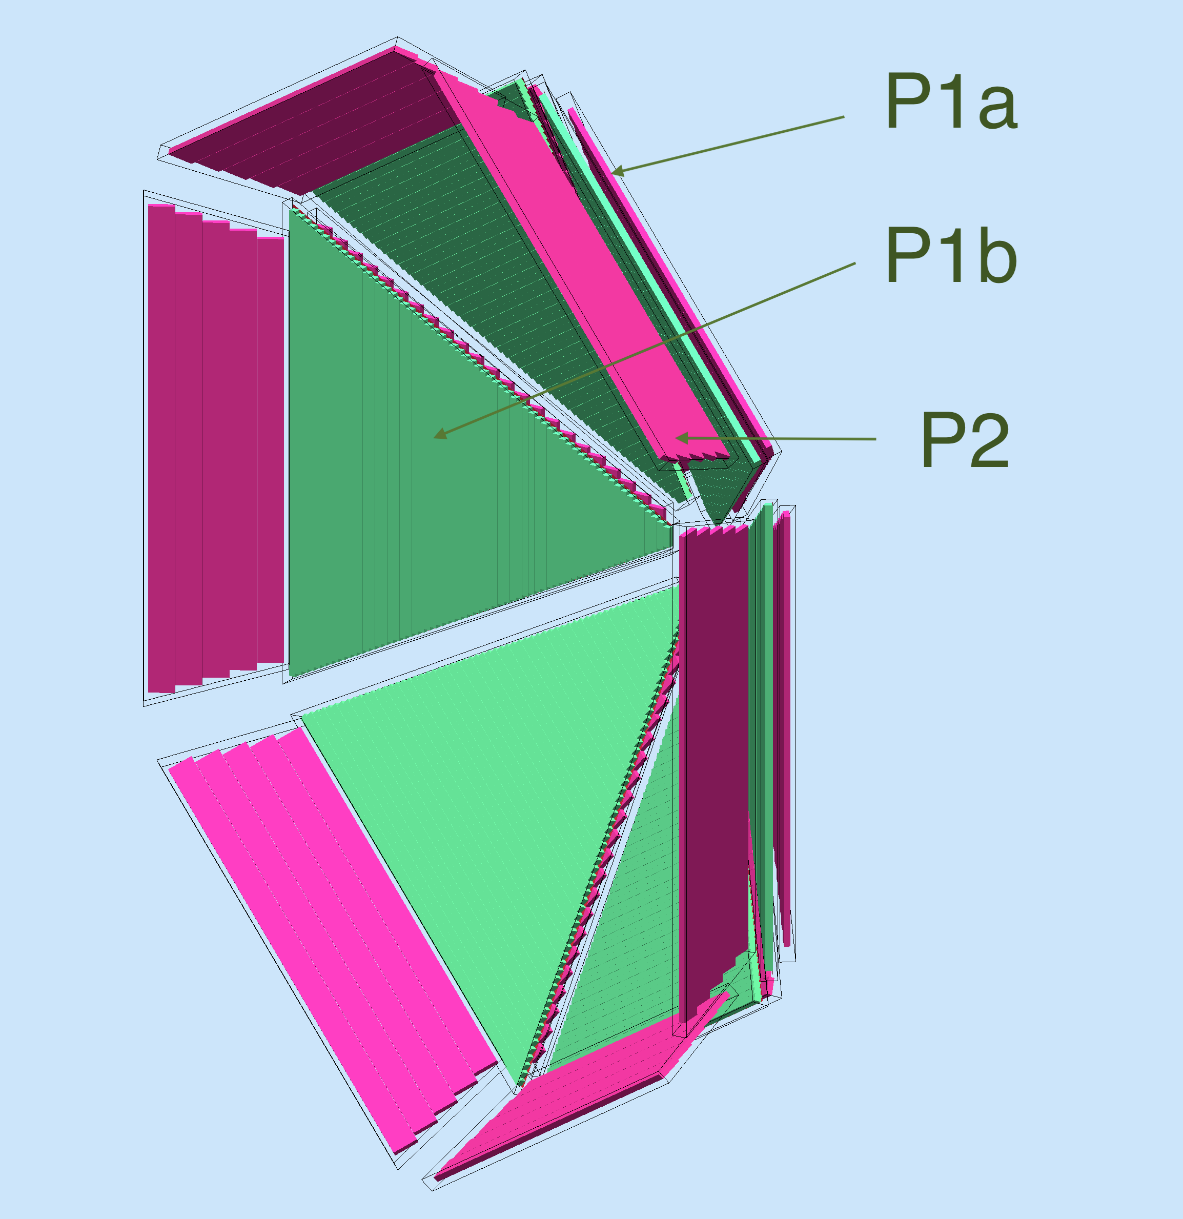

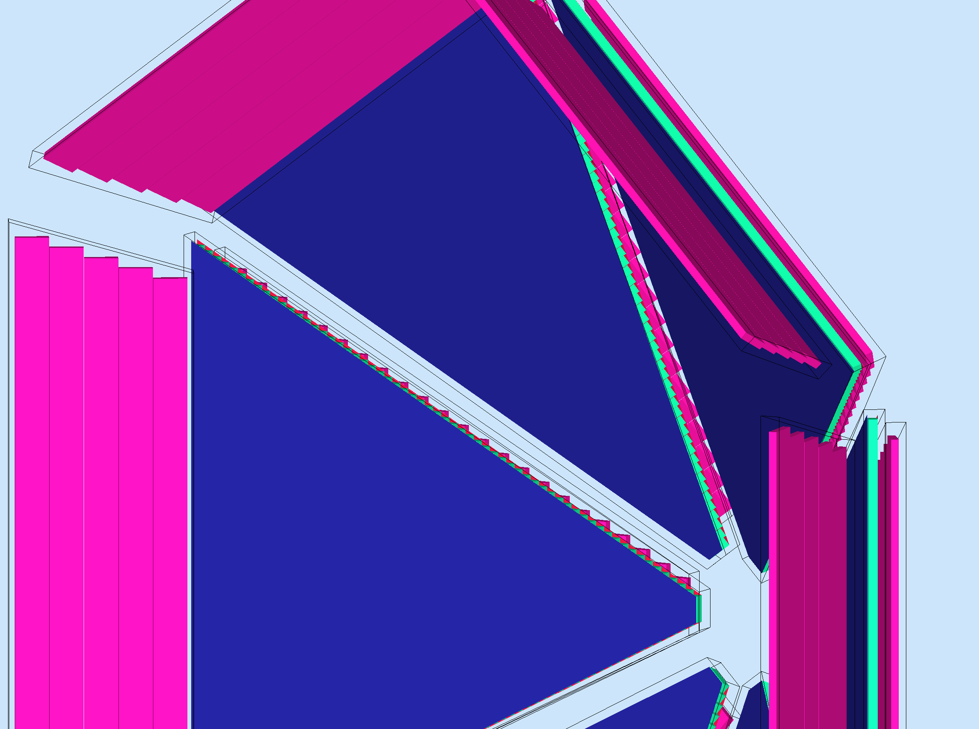

Figure 1. Top: The FTOF panels in the simulation, without any shielding. Bottom left: the FTOF with a 1-mm-thick lead in front of panel-1b. Bottom right: a zoomed in picture shows the position and thickness of the lead sheet.

**Paddle Background Rates**

In Figure 2 (top) the total rates as a function of p1b FTOF paddle number are presented for each of the shielding configurations. The bottom of this figure shows only the electromagnetic rates, showing that they make up most of these rates. The shielding configuration do an increasingly good job at stopping a lot of these particles. However, see Figure 3, about 90% of this rate was below the FTOF 1 MeV readout threshold.

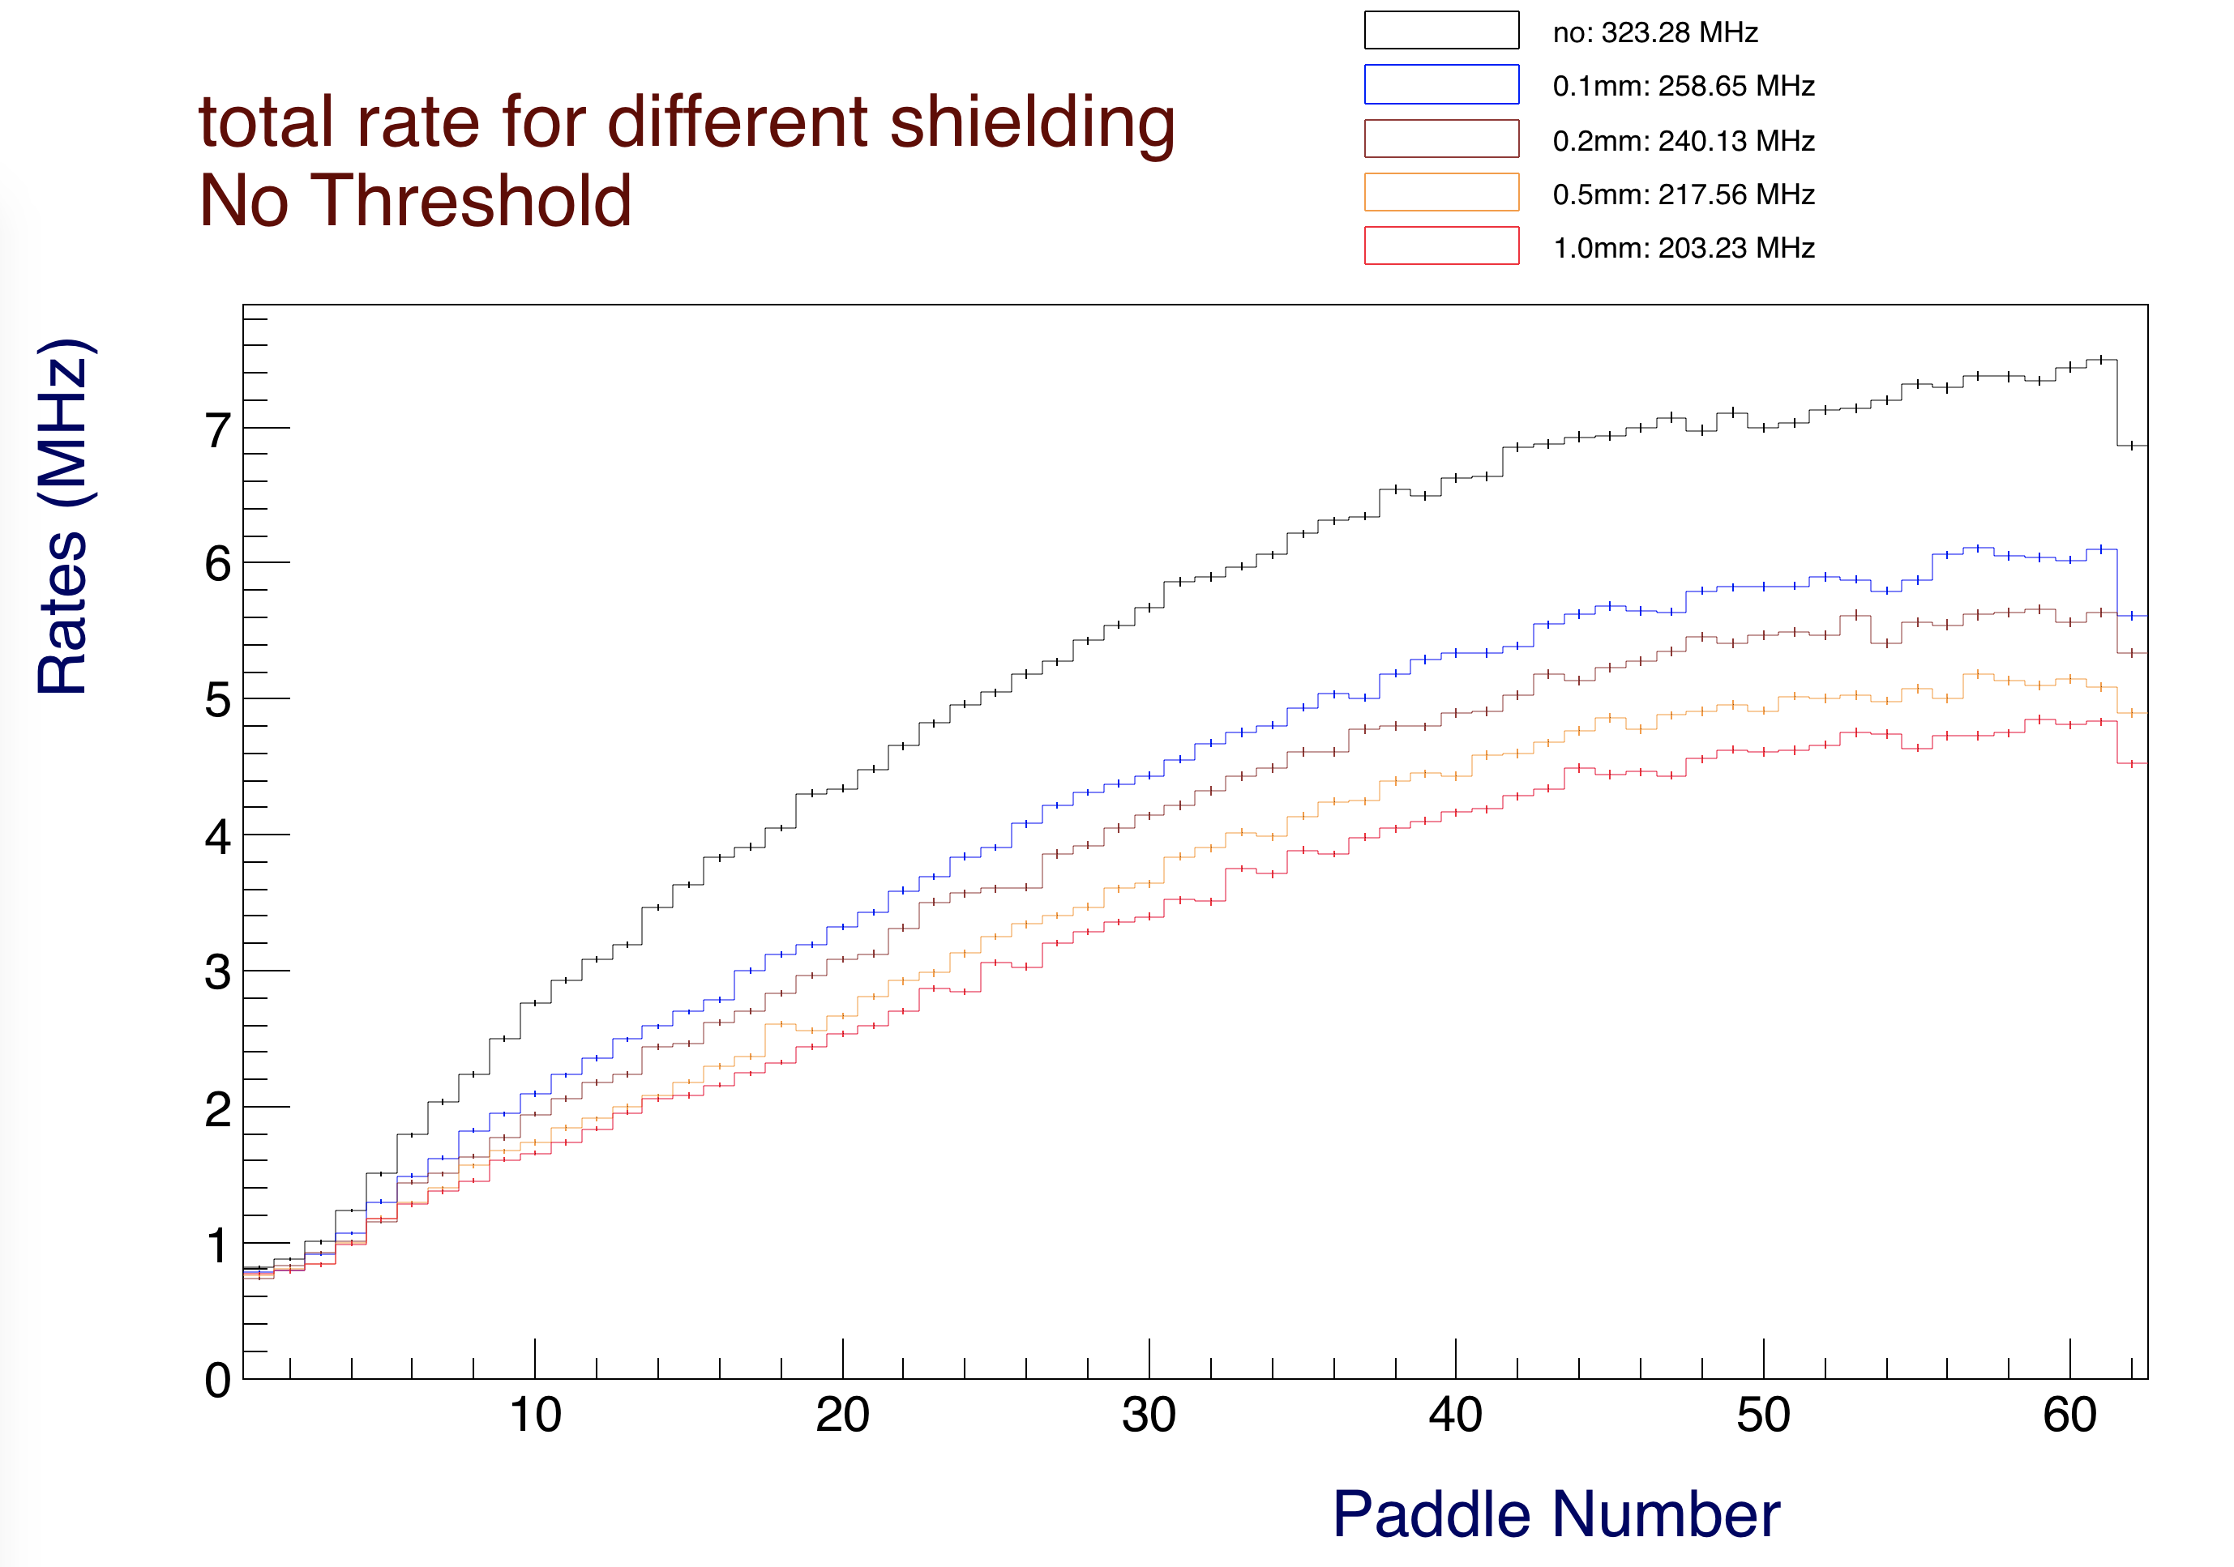

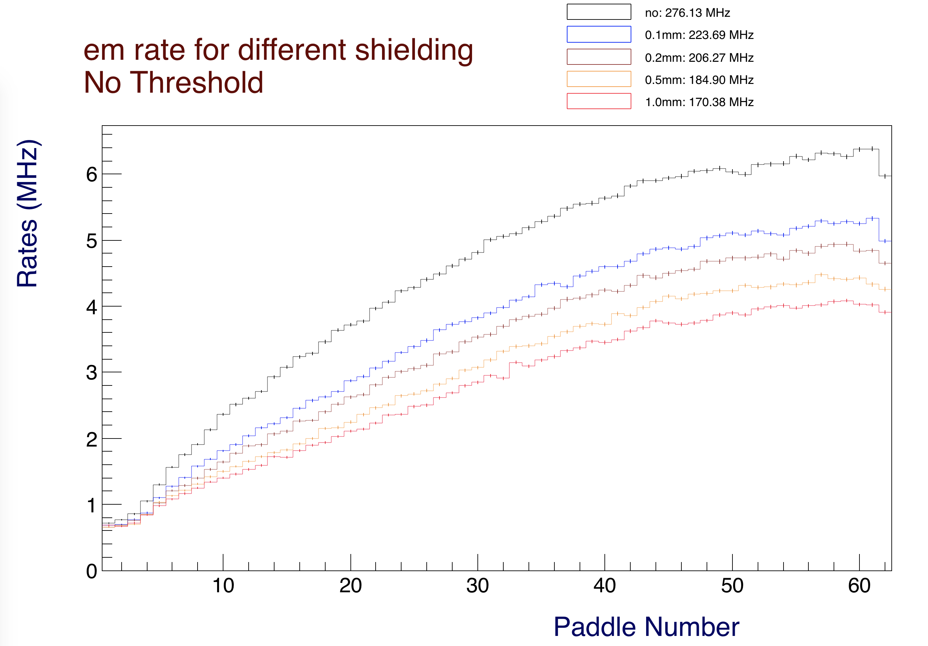

*Figure 2. Top: Rates for all particles as a function of paddle number in FTOF panel-1b in one representative sector. The legend reports the average paddle rate in MHz. The total rate, shown in the legend, is the integral of these curves. For example, the total rate in FTOF for the configuration with the 100 m Pb shield is roughly 224 MHz. Bottom: lepton and gamma rates make up most of the FTOF rates. These plots are for the full nominal CLAS12 operating luminosity.*

In Figure 3 the total rates are shown with a 1 MeV energy threshold is applied (the same as used for the detector readout). One can see that various shielding thickness has a small (~1%) effect on the total rate.

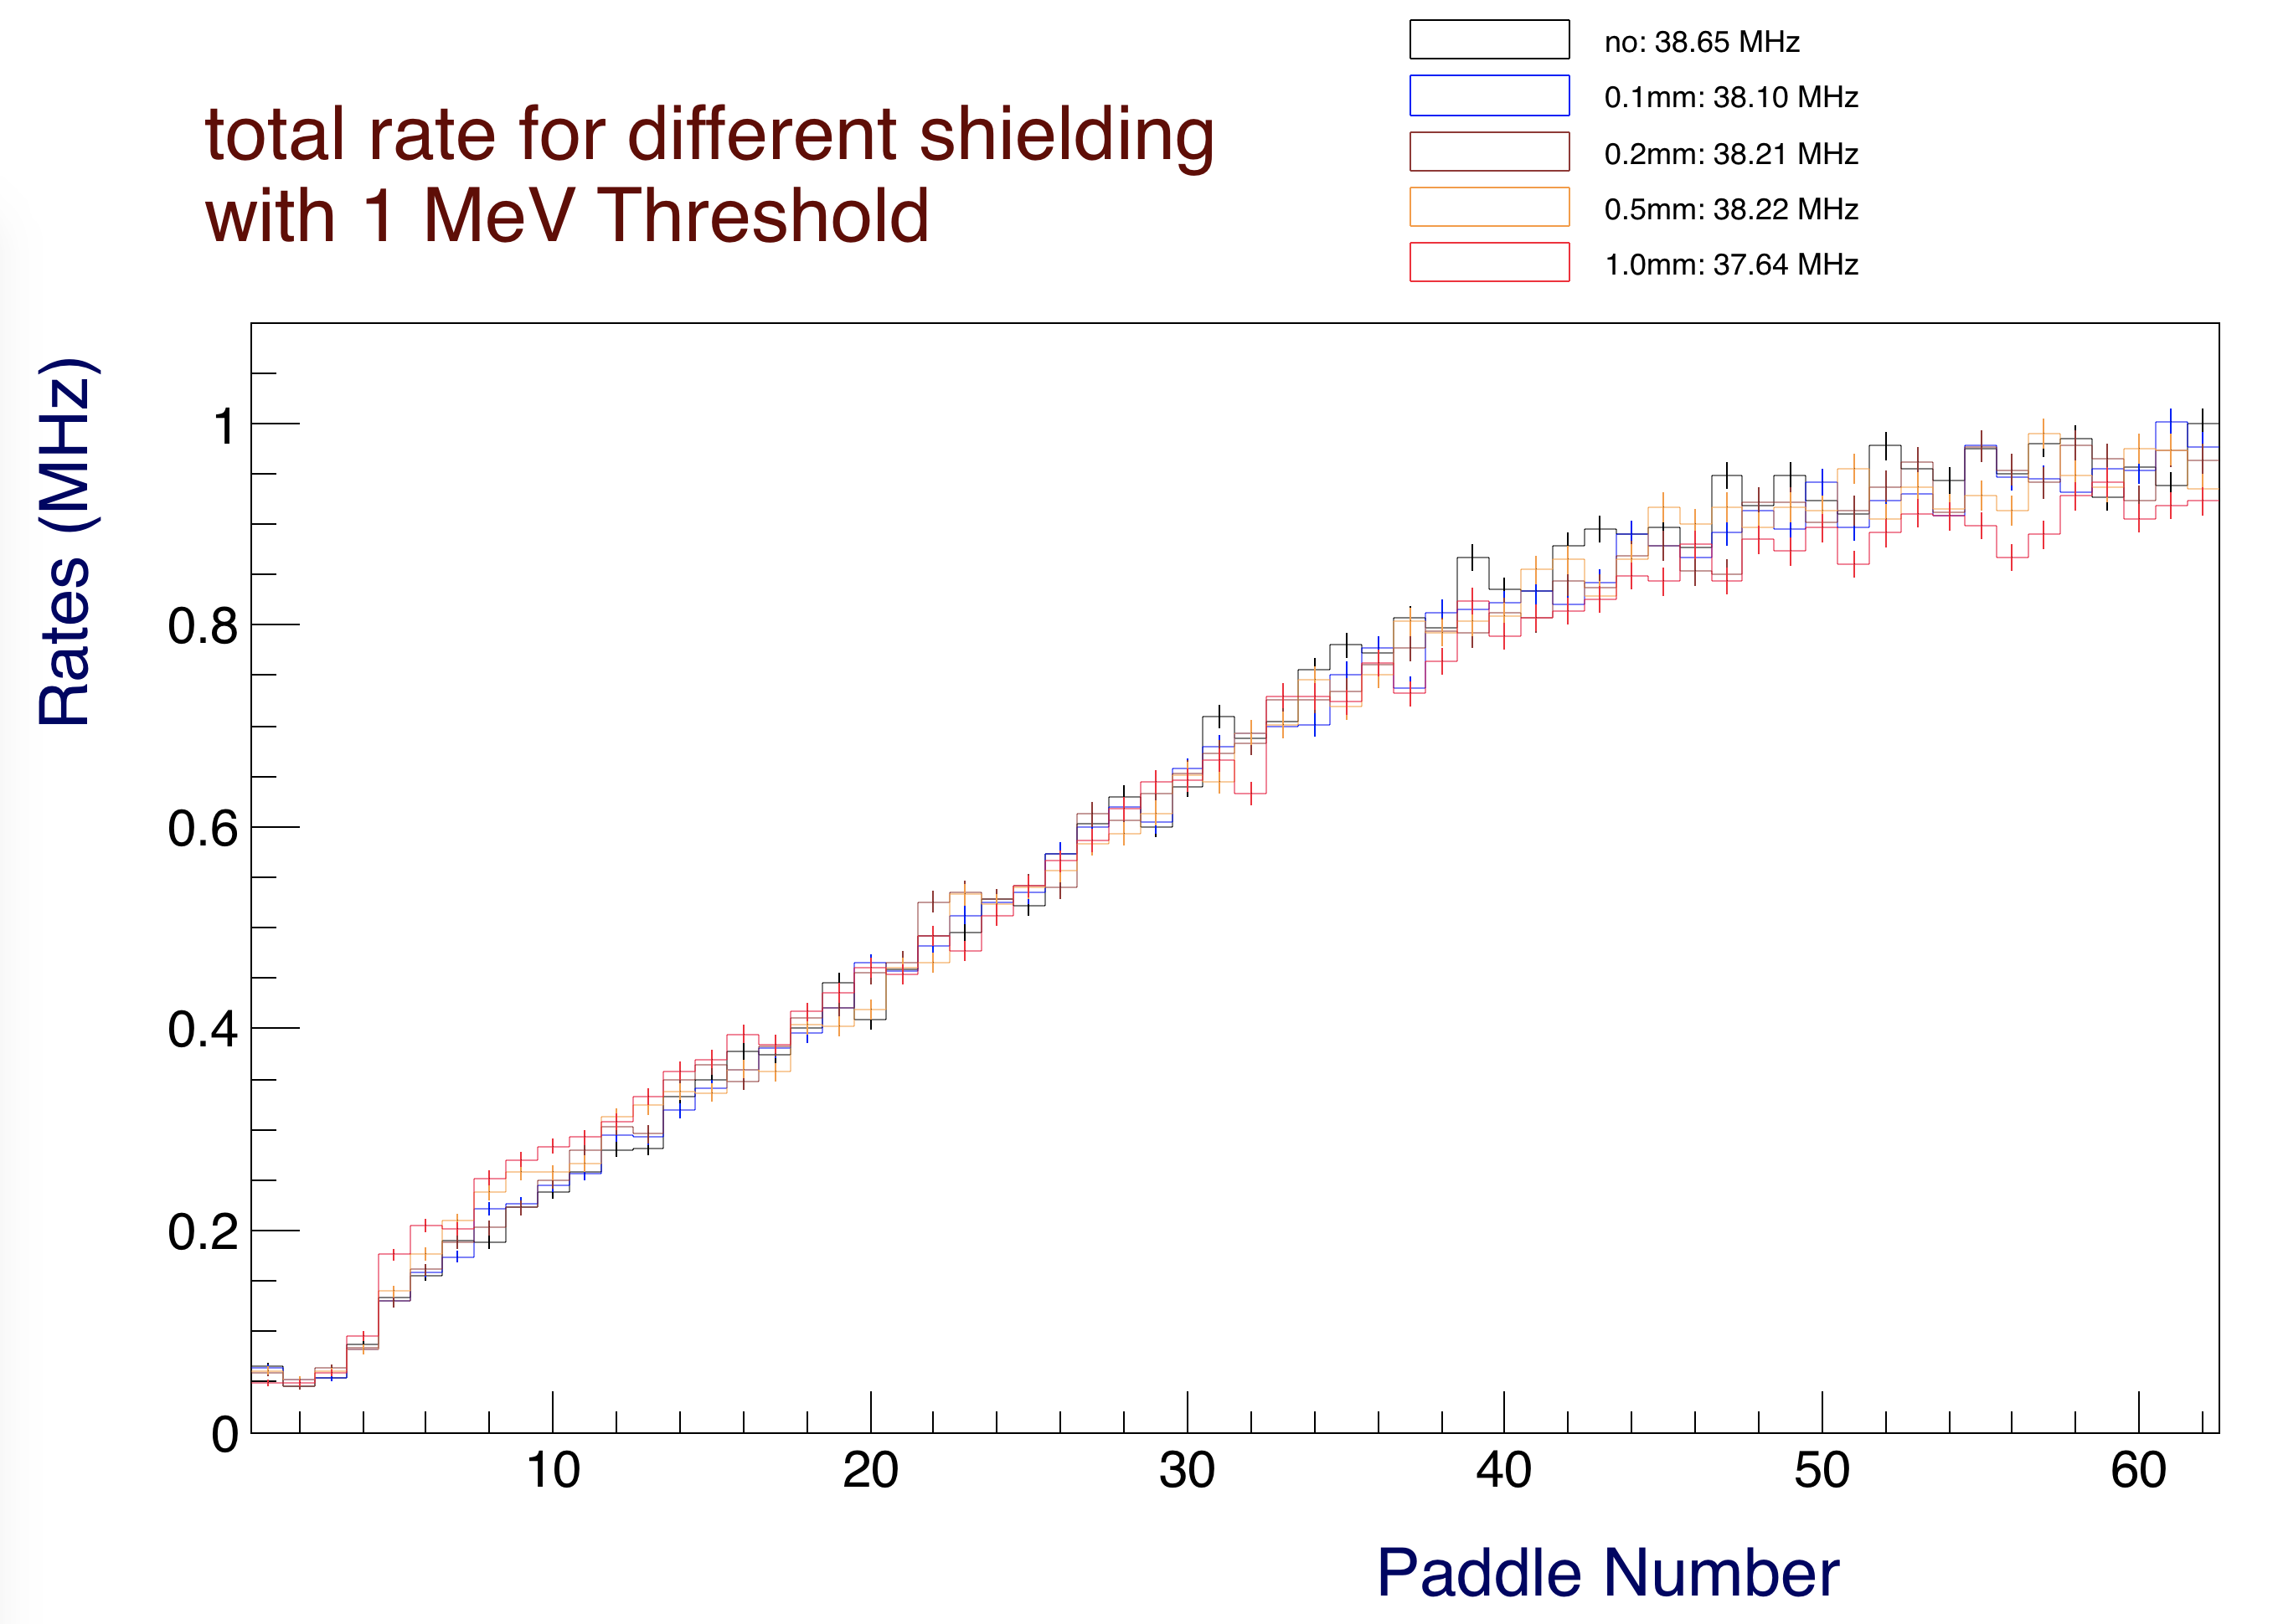

*Figure 3: FTOF panel-1b rates above 1 MeV of deposited energy showing that the shielding material increases the counter rates. This plot is for the full nominal CLAS12 operating luminosity.*

In Figure 4 is shown that the background producing the above threshold rates is composed mostly by leptons. The gamma rates above threshold are relatively very small but they are the only rates that show significant reduction with increased shielding. Hadrons make up about 5% of the rate and their rate slightly increases with the shield thickness but not as dramatically as for a similar study performed for the CTOF detector [2].

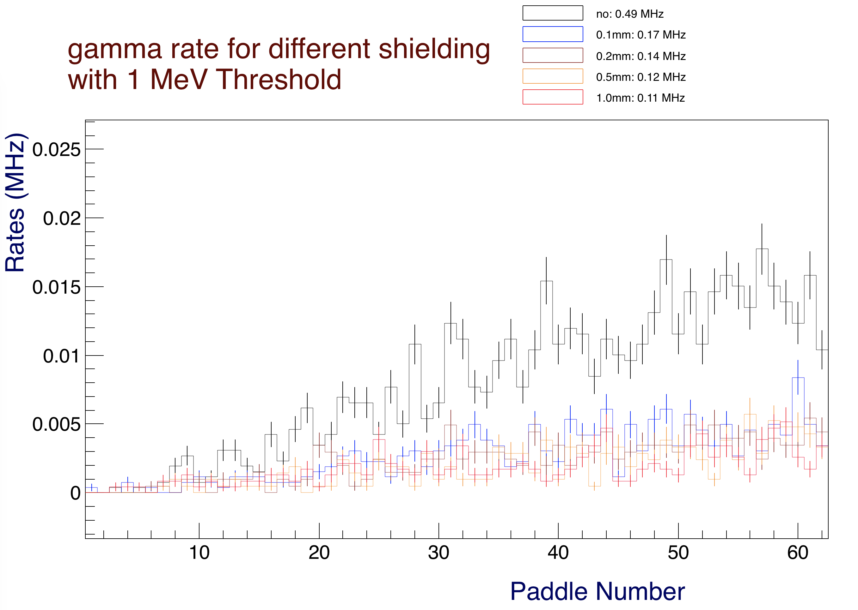

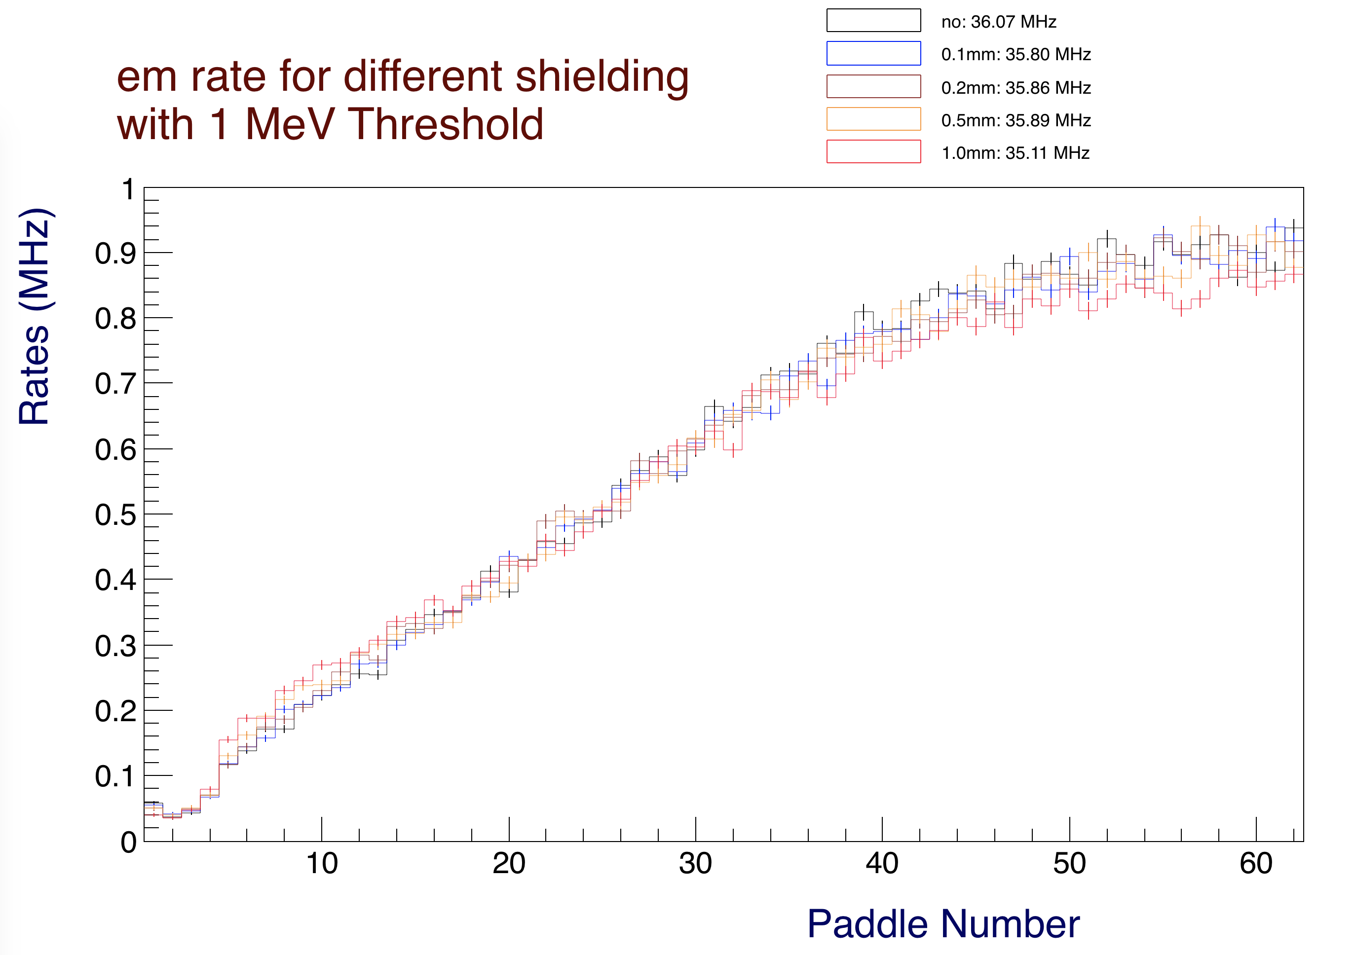

*Figure 4: FTOF gamma (top) and lepton (bottom) rates above 1 MeV of deposited energy for FTOF panel-1b. Most of the rate total shown in Figure 3 is due to leptons. The hadronic rates slightly increase with shield thickness from 2.1 MHz (no shield) to 2.4 MHz (1 mm shield). These plots are for the full nominal CLAS12 operating luminosity.*

**Deposited Energy Rates**

In Figure 5 the total deposited energy is shown. The particles generated by the various shielding configurations have a peak of energy deposited between 5 and 10 MeV. These are the particles either generated in the shields, or that the shields cannot stop.

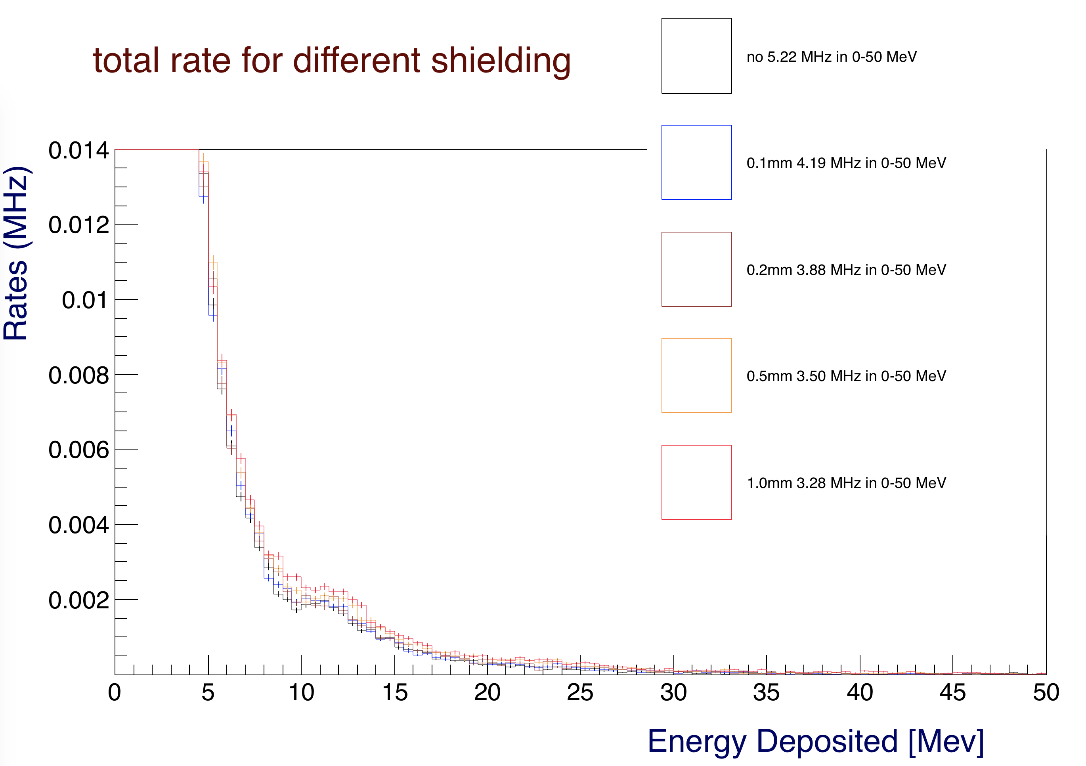

*Figure 5: Deposited energy spectra in FTOF panel-1b for the different shielding configurations. This plot is for the full nominal CLAS12 operating luminosity.*

In Figure 6 the energy deposited below 120 keV is plotted. This is the energy range where the shields are more effective and can reduce rates by a factor of 3 or more.

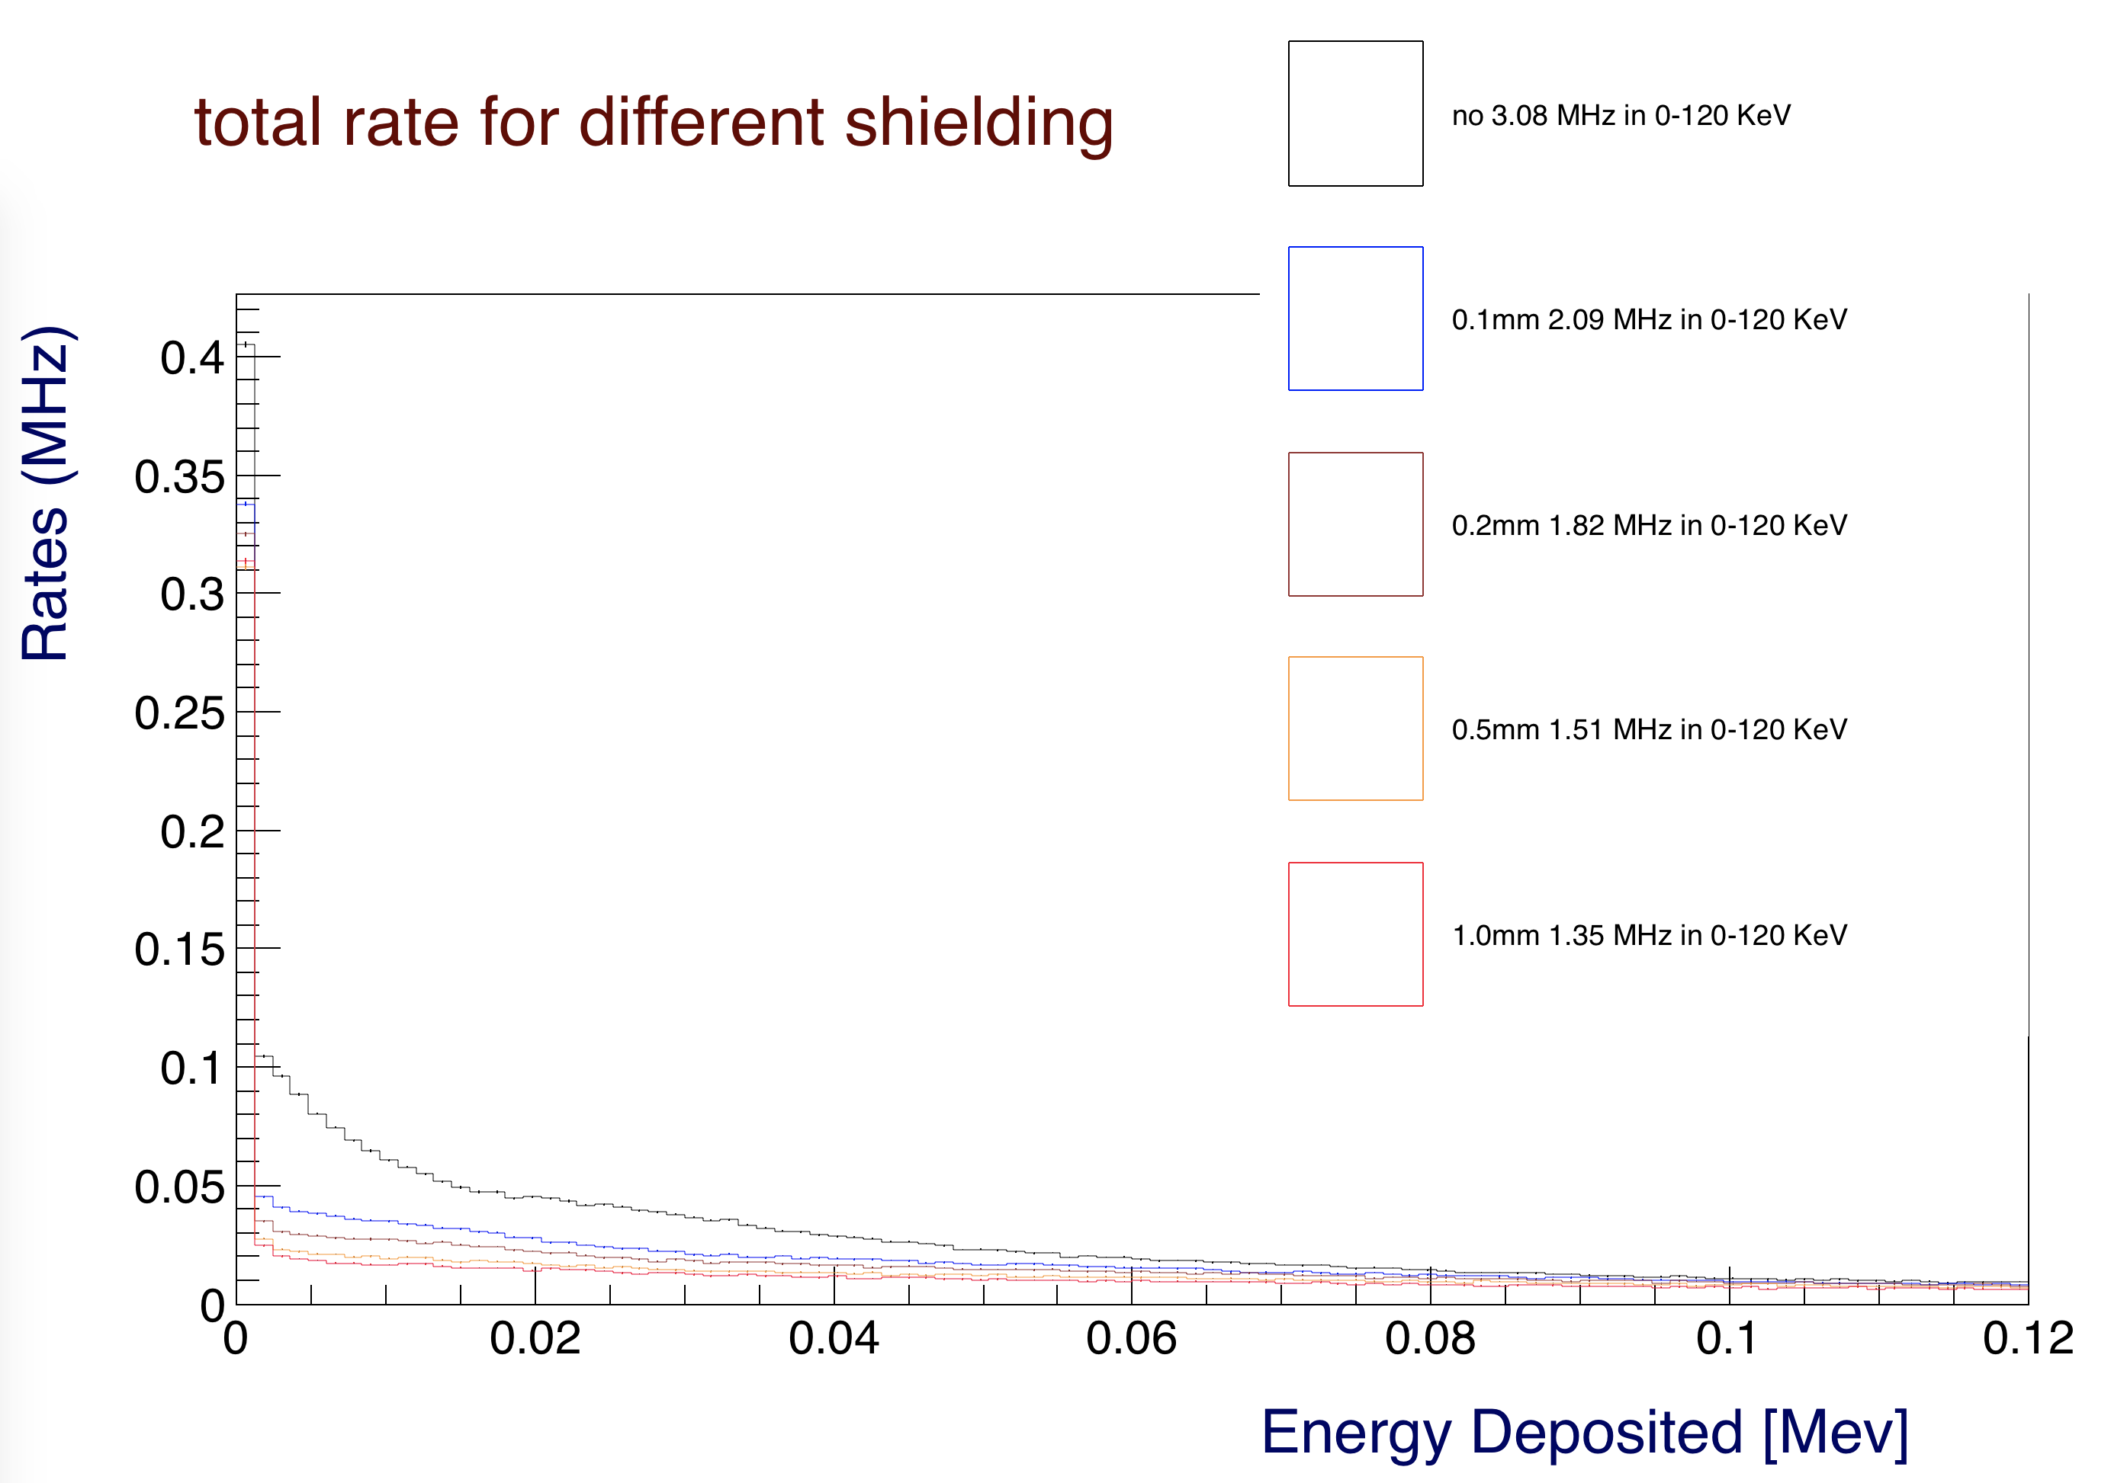

*Figure 6: The deposited energy in FTOF panel-1b for the different shielding configurations, up to 120 keV. This plot is for the full nominal CLAS12 operating luminosity.*

**Background Origin**

The transverse vs. longitudinal vertex of the origin coordinates of the particles hitting FTOF without and with a 1 MeV energy threshold is plotted in Figures 7, 8, and 9 for the no shield, 0.1 mm and 1.0 mm lead shields, respectively. By comparing the three figures it is apparent that additional shielding stops some low energy particles, while serving as a source for other low energy particles.

The one-dimensional longitudinal vertex distributions for all configurations are shown in Figure 9b.

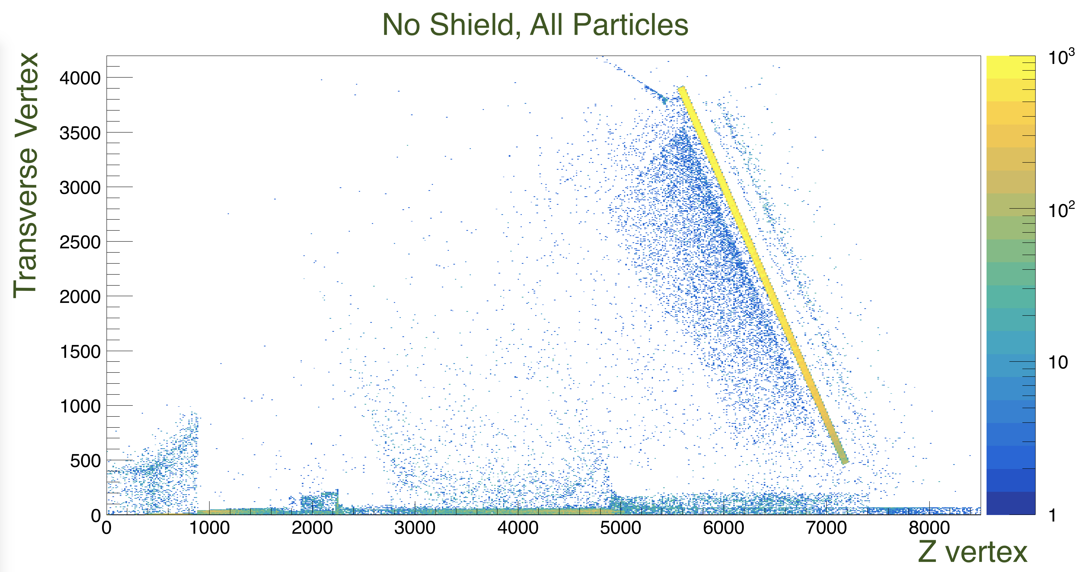

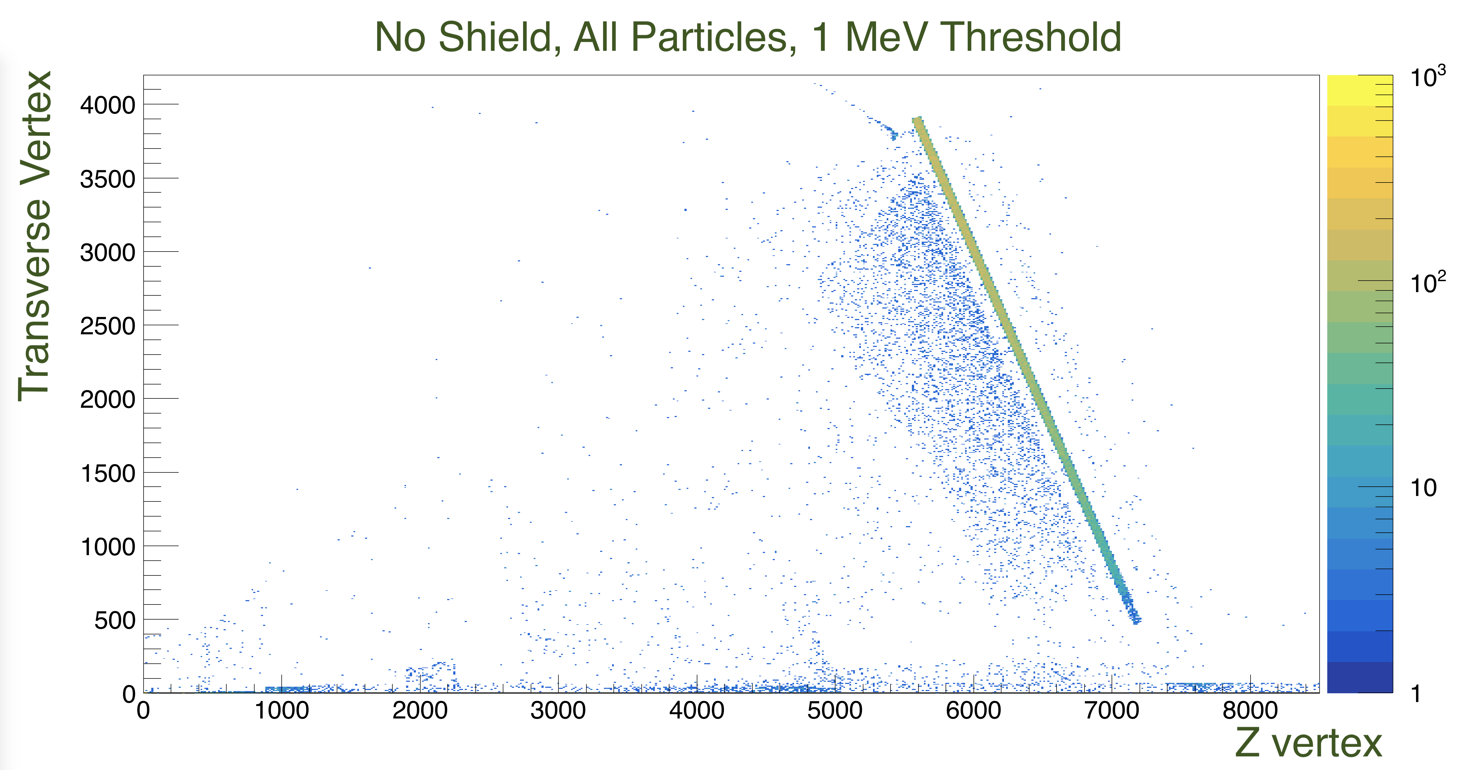

*Figure 7: Transverse vs. longitudinal vertex of particles hitting FTOF panel-1b. The z-scale maximum is fixed at 1000 counts. This is the configuration without any shielding in front of FTOF panel-1b. Top: no threshold. Bottom: 1 MeV threshold.*

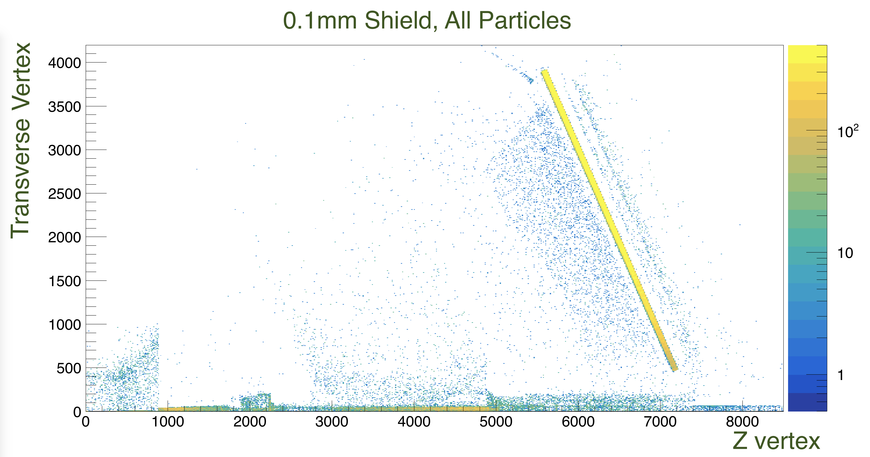

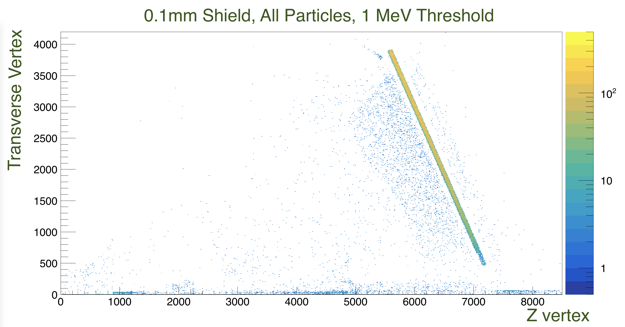

*Figure 8: Transverse vs. longitudinal vertex of particles hitting FTOF panel-1b. The z-scale maximum is fixed at 500 counts. This configuration has a 0.1mm lead sheet in front of the FTOF panel-1b. Top: no threshold. Bottom: 1 MeV threshold.*

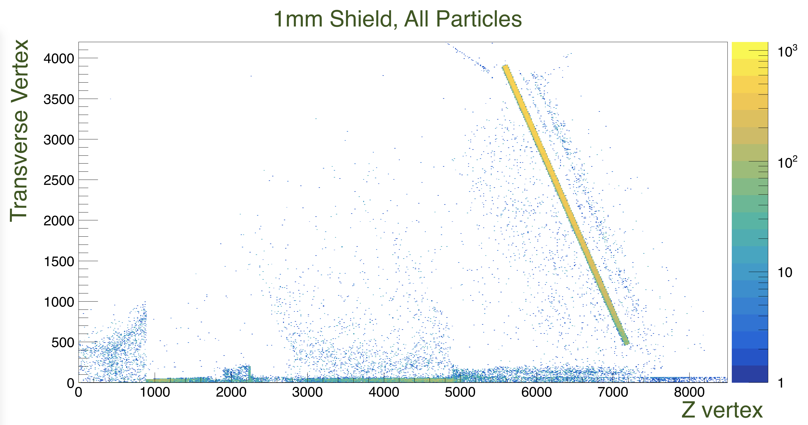

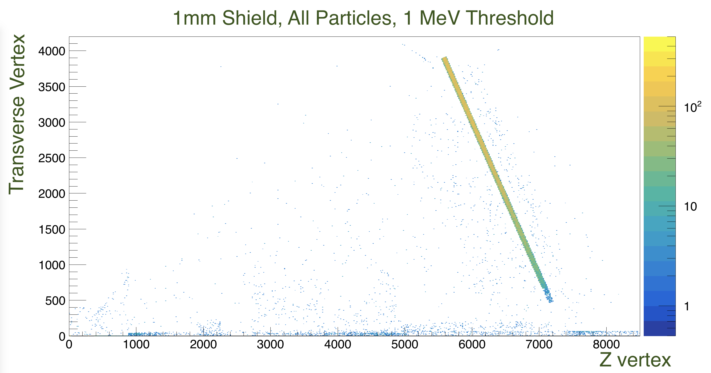

*Figure 9: Transverse vs. longitudinal vertex of particles hitting FTOF panel-1b. The z-scale maximum is fixed at 500 counts. This configuration has a 1mm lead sheet in front of the FTOF panel-1b. Top: no threshold. Bottom: 1 MeV threshold.*

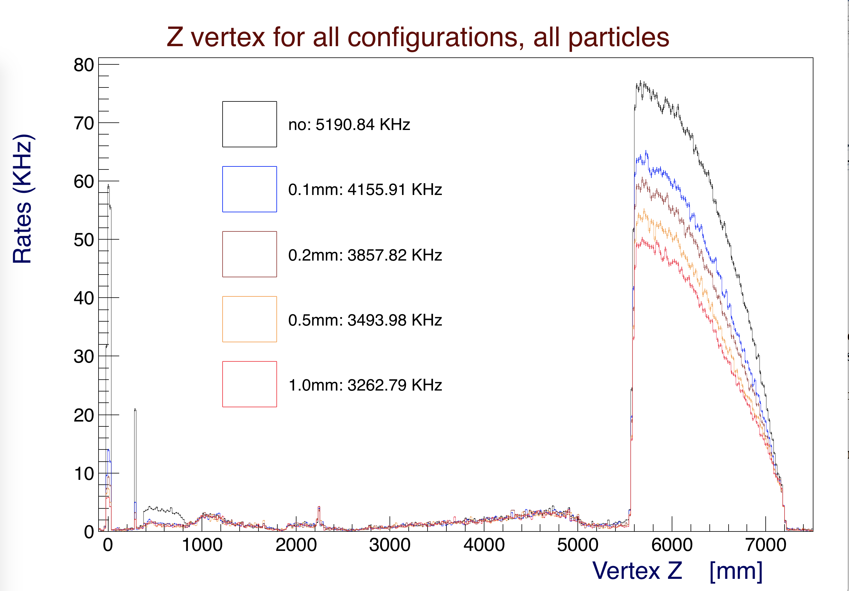

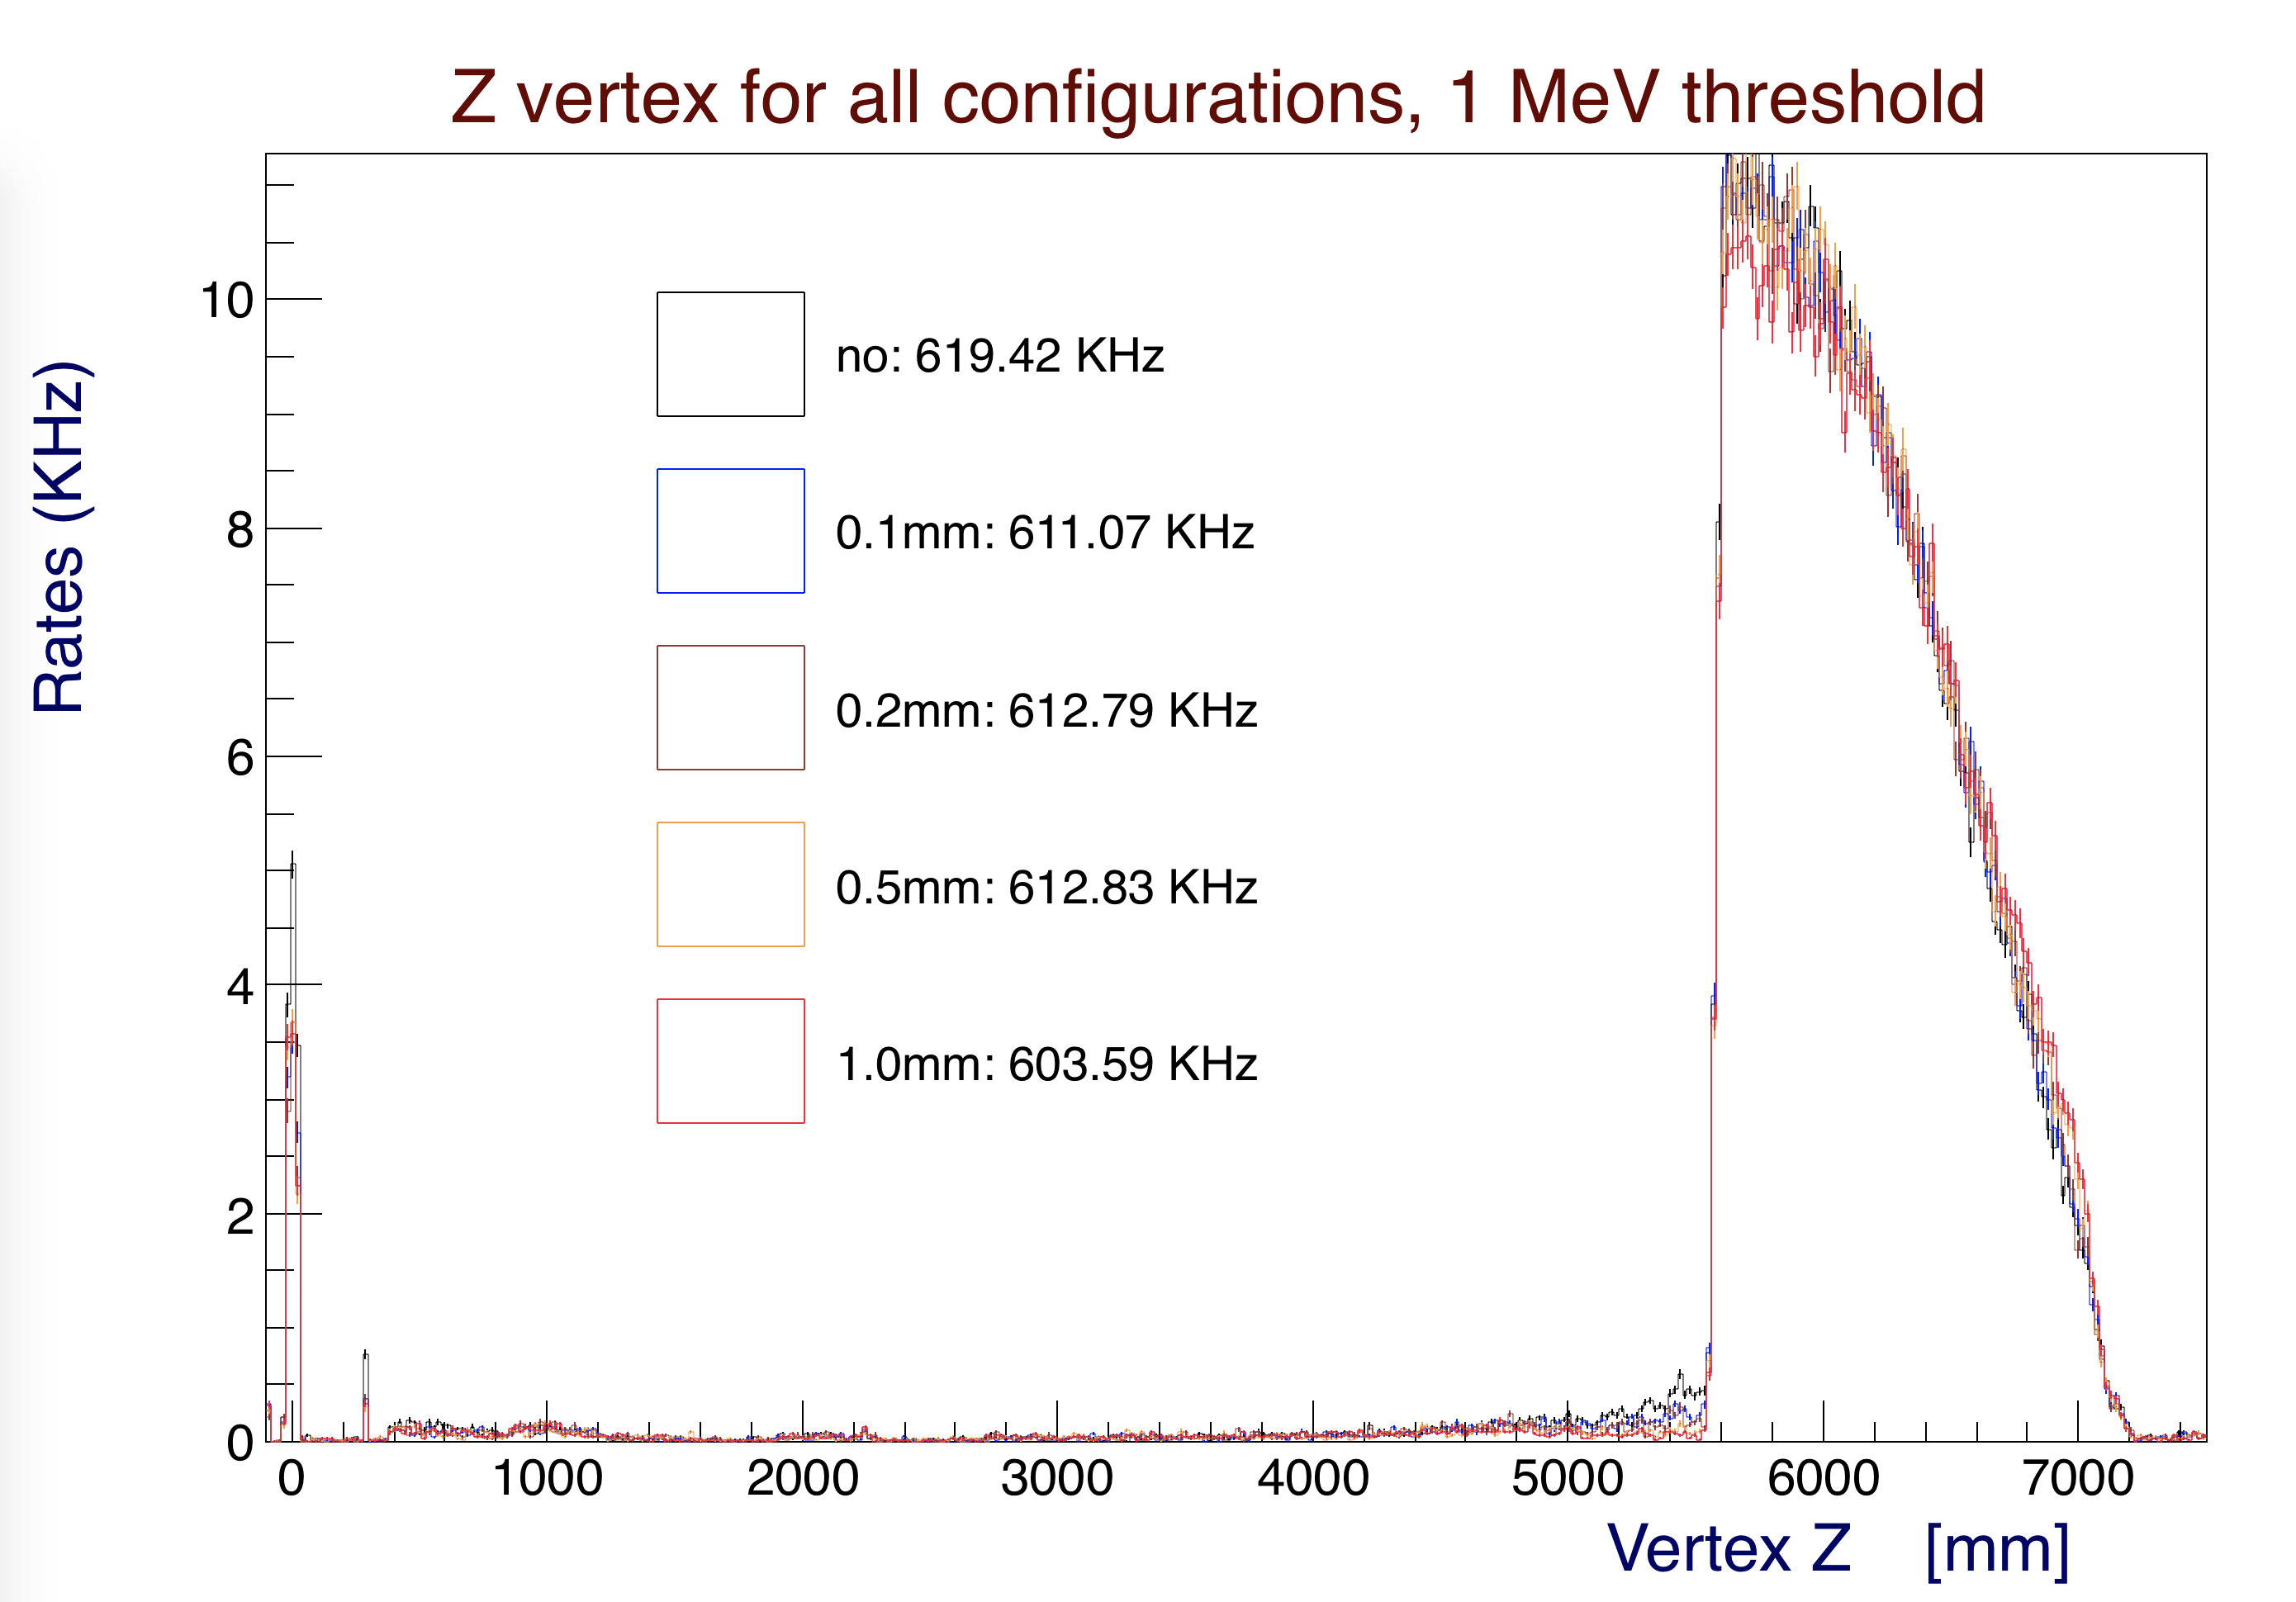

*Figure 9b: Longitudinal vertex of particles hitting FTOF panel-1b. Top: no threshold. Bottom: 1 MeV threshold. The shields stop a lot of low energy particles. Between z=0.4 m and 1 m some low energy particles produced in the beamline shield could be stopped by the FTOF shield.*

**Particle Momenta**

The particle rates as a function of momentum are shown in Figures 10, 11, and 12 for no shield, 0.1 mm, and 1 mm lead shields, respectively. The additional shielding does stop low energy particles and does not seem to increase background rates. The rates are zoomed in between the momentum range 0-2 MeV/c in Figures 13, 14, and 15 for the same configurations.

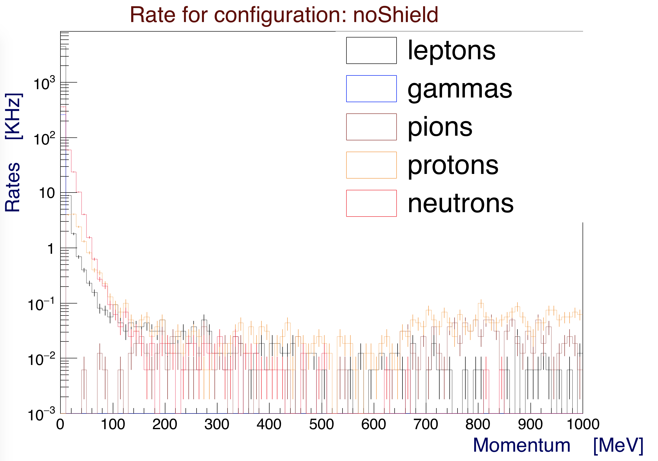

*Figure 10: Rates as a function of momentum for particles hitting FTOF panel-1b. This is the configuration with no shielding. This plot is for the full nominal CLAS12 operating luminosity.*

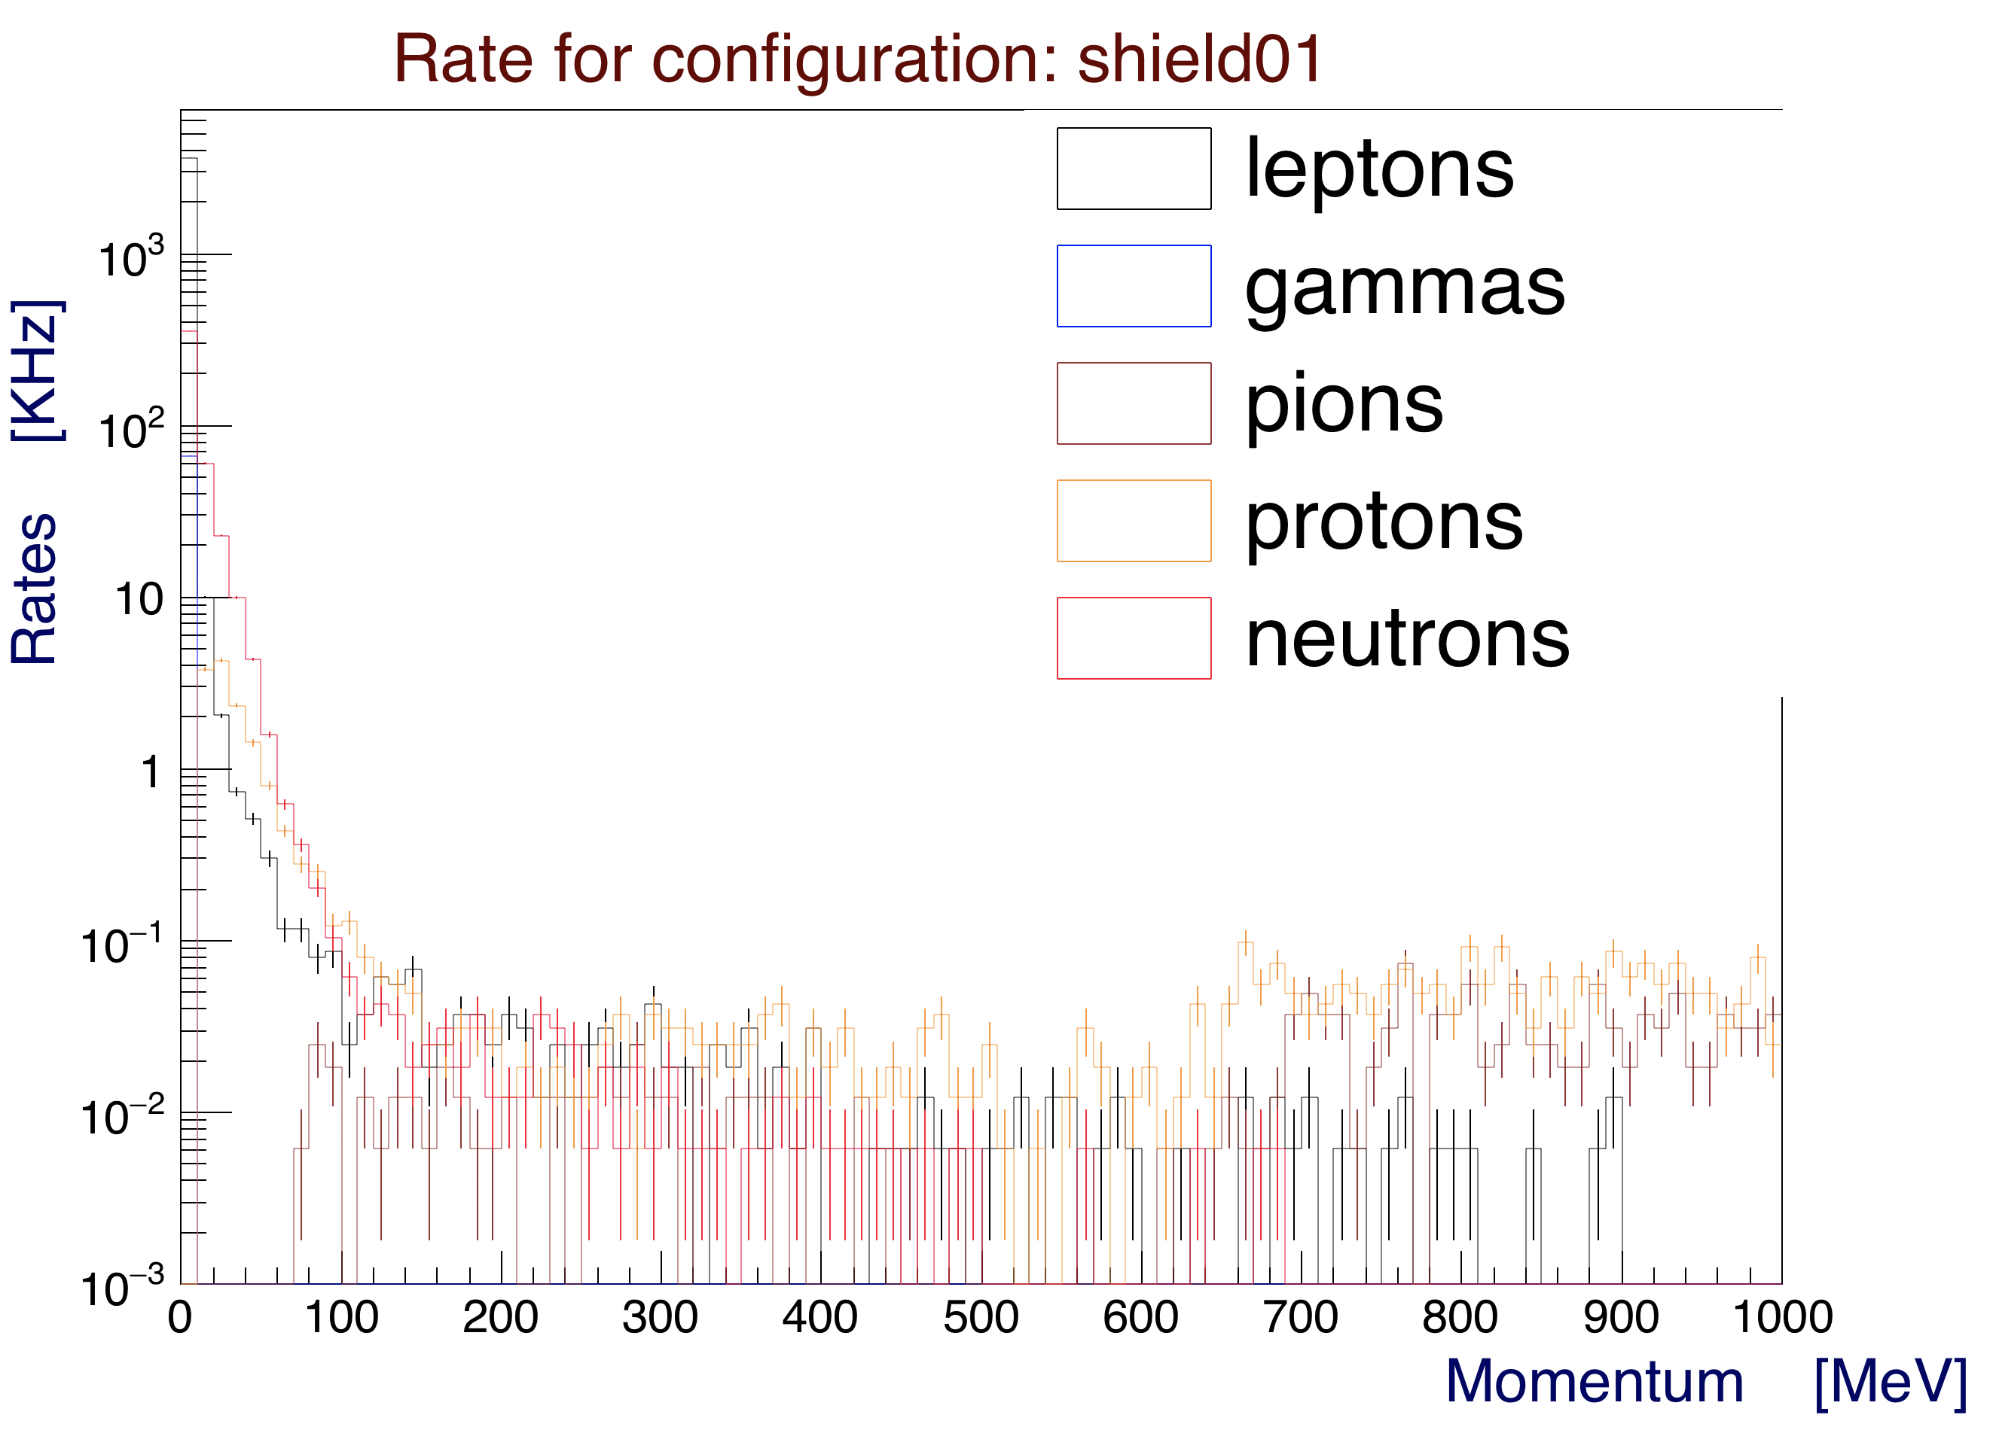

*Figure 11: Rates as a function of momentum for particles hitting FTOF panel-1b. An additional 0.1 mm lead shield is added in front of panel 1b. It doesn’t seem to have a significant effect on rates. This plot is for the full nominal CLAS12 operating luminosity.*

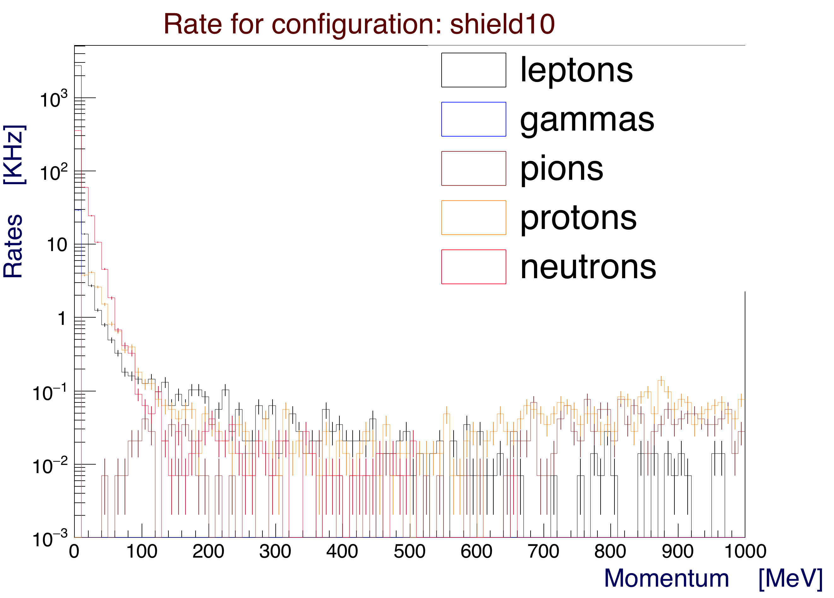

*Figure 12: Rates as a function of momentum for particles hitting FTOF panel-1b. An additional 1 mm lead shield is added in front of panel 1b. It doesn’t seem to have a significant effect on rates. This plot is for the full nominal CLAS12 operating luminosity.*

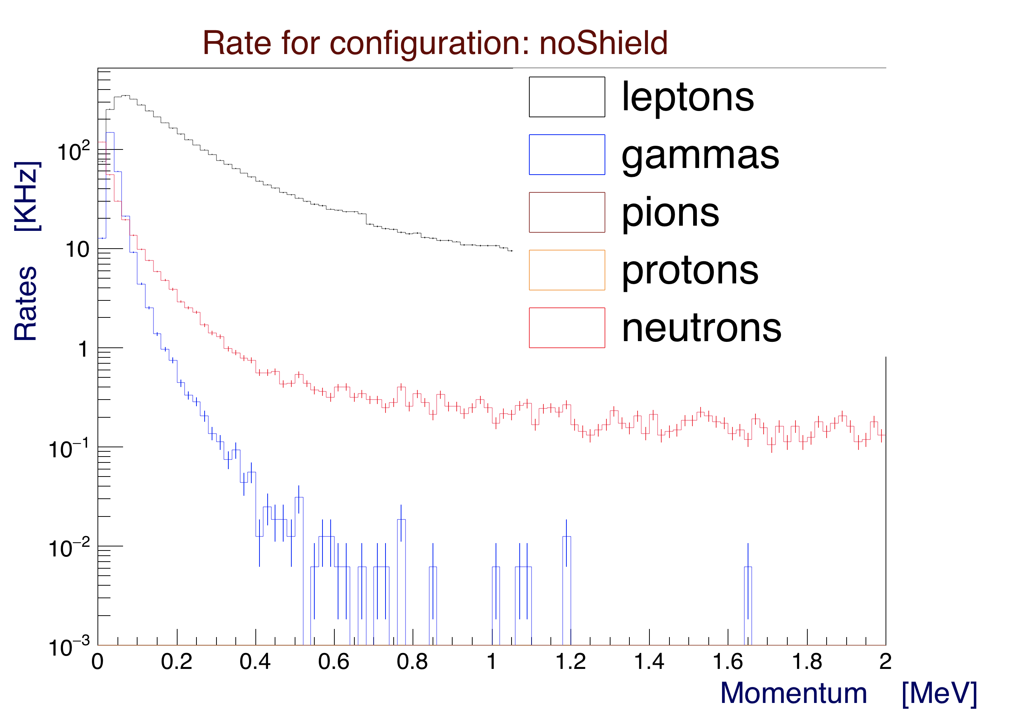

*Figure 13: Rates as a function of momentum for particles hitting FTOF panel-1b, zoomed in between 0 and 2 MeV. This is the configuration with no shielding. This plot is for the full nominal CLAS12 operating luminosity.*

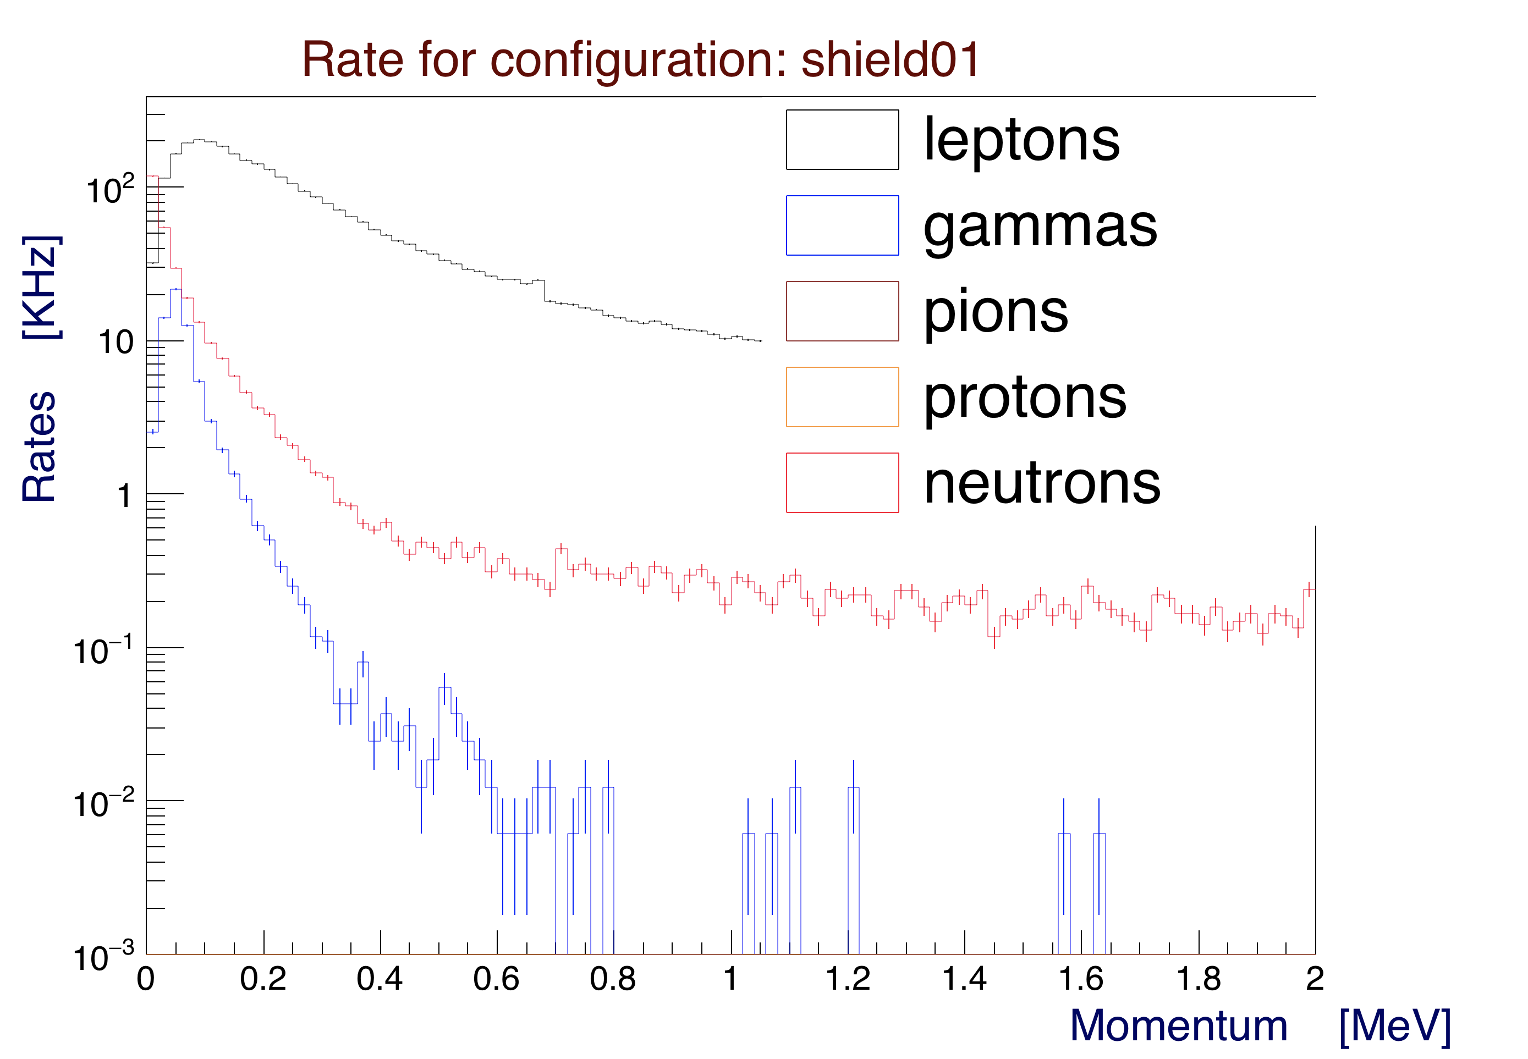

*Figure 14: Rates as a function of momentum for particles hitting FTOF panel-1b, zoomed in between 0 and 2 MeV. An additional 0.1 mm lead shield is added in front of panel-1b. It reduces e.m. rates by about a factor of 2 compared to no shield. This plot is for the full nominal CLAS12 operating luminosity.*

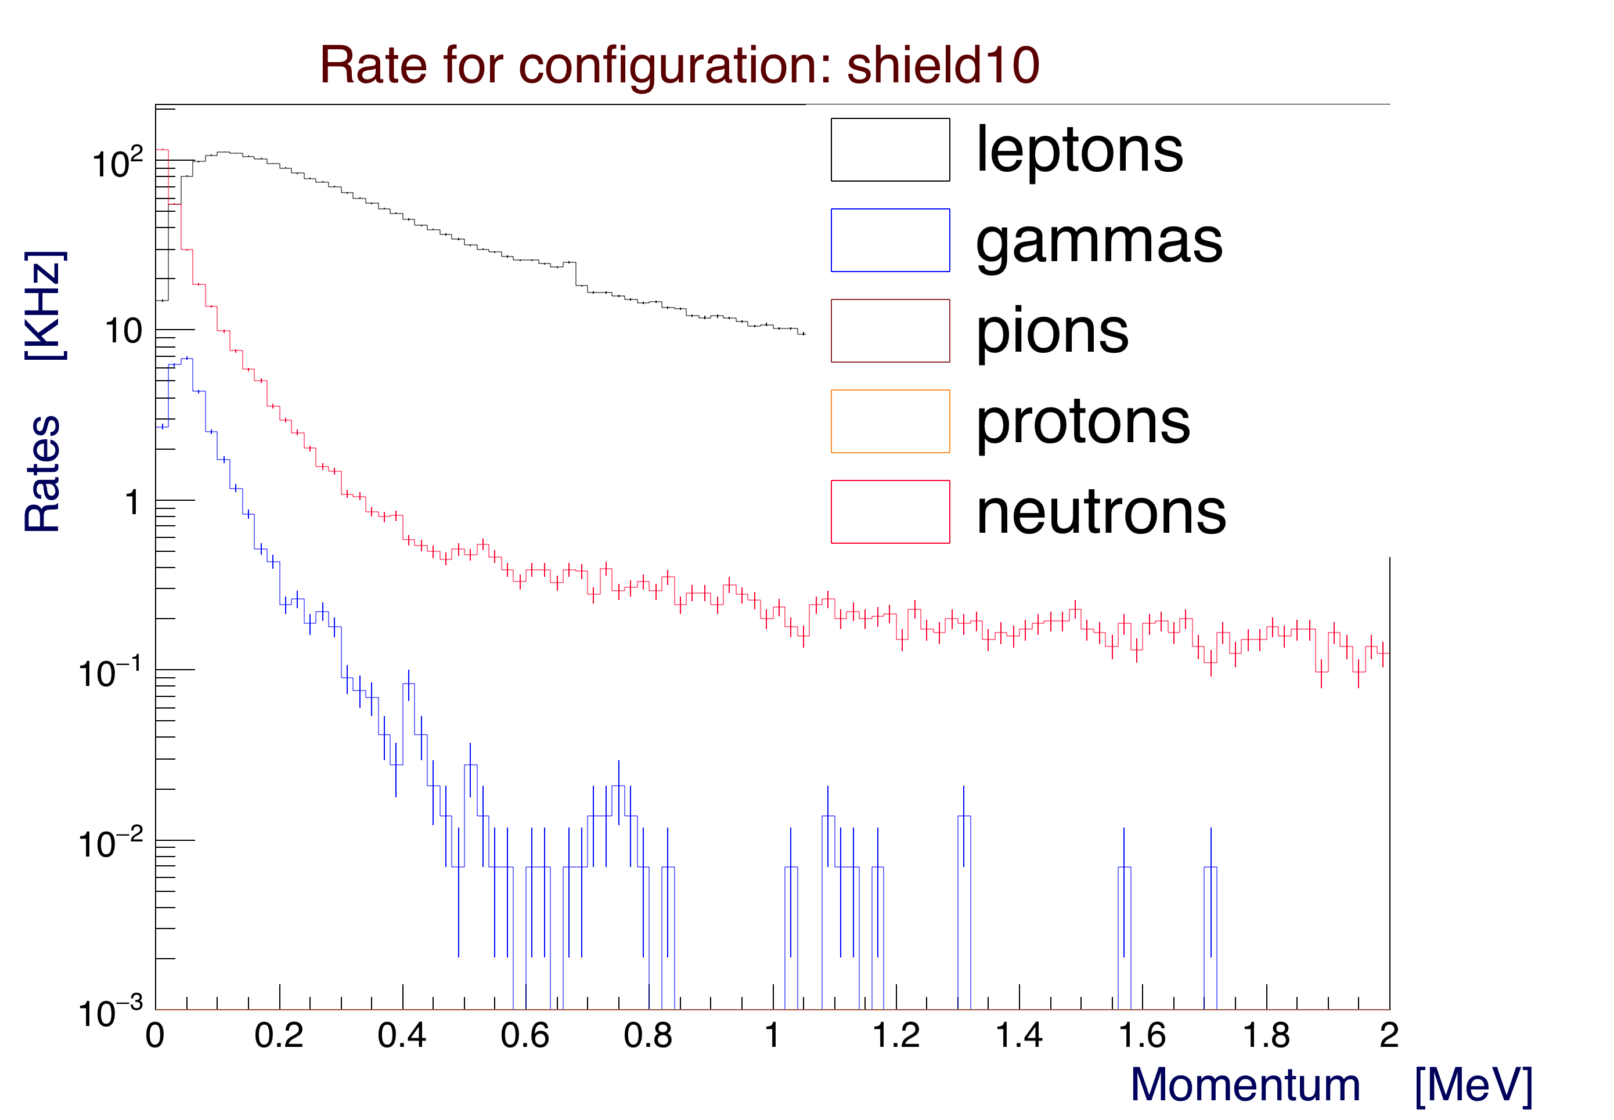

*Figure 15: Rates as a function of momentum for particles hitting FTOF panel-1b, zoomed in between 0 and 2 MeV/c. An additional 1 mm lead shield is added in front of panel-1b. It reduces e.m. rates by about a factor of 4 compared to no shield. This plot is for the full nominal CLAS12 operating luminosity.*

**Simulated FTOF Left / Right Scaler Rates**

The rates of events that deposit more than 1 MeV of energy at the face of the left and right FTOF panel-1b PMTs were calculated by applying the paddle attenuation length to the total energy deposited in the scintillators. The length and attenuation length values employed are reported in Appendix A.

These rates are shown in Figures 16 and 17 for the left and right PMTs, respectively. We report both to show that they are identical, as expected.

There is no significant scaler rate reduction for any of the shield configurations considered. In Figures 16 and 17, as well as in Figures 3 and 4, it seems that the thickest shield produces some secondaries at small angles while providing some shielding at higher angles.

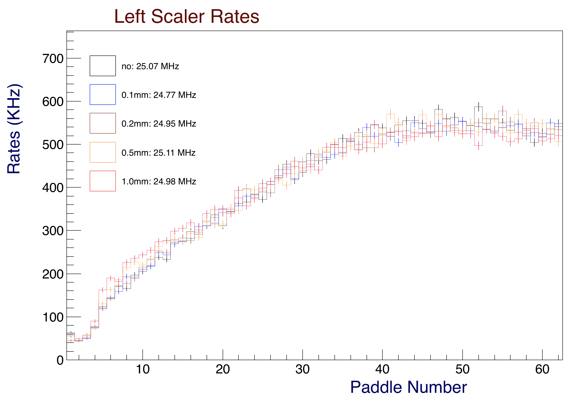

*Figure 16: Left scaler rates for the FTOF panel-1b PMTs for different configurations with a 1 MeV energy threshold. There is no significant improvement for any shield configuration. This plot is for the full nominal CLAS12 operating luminosity.*

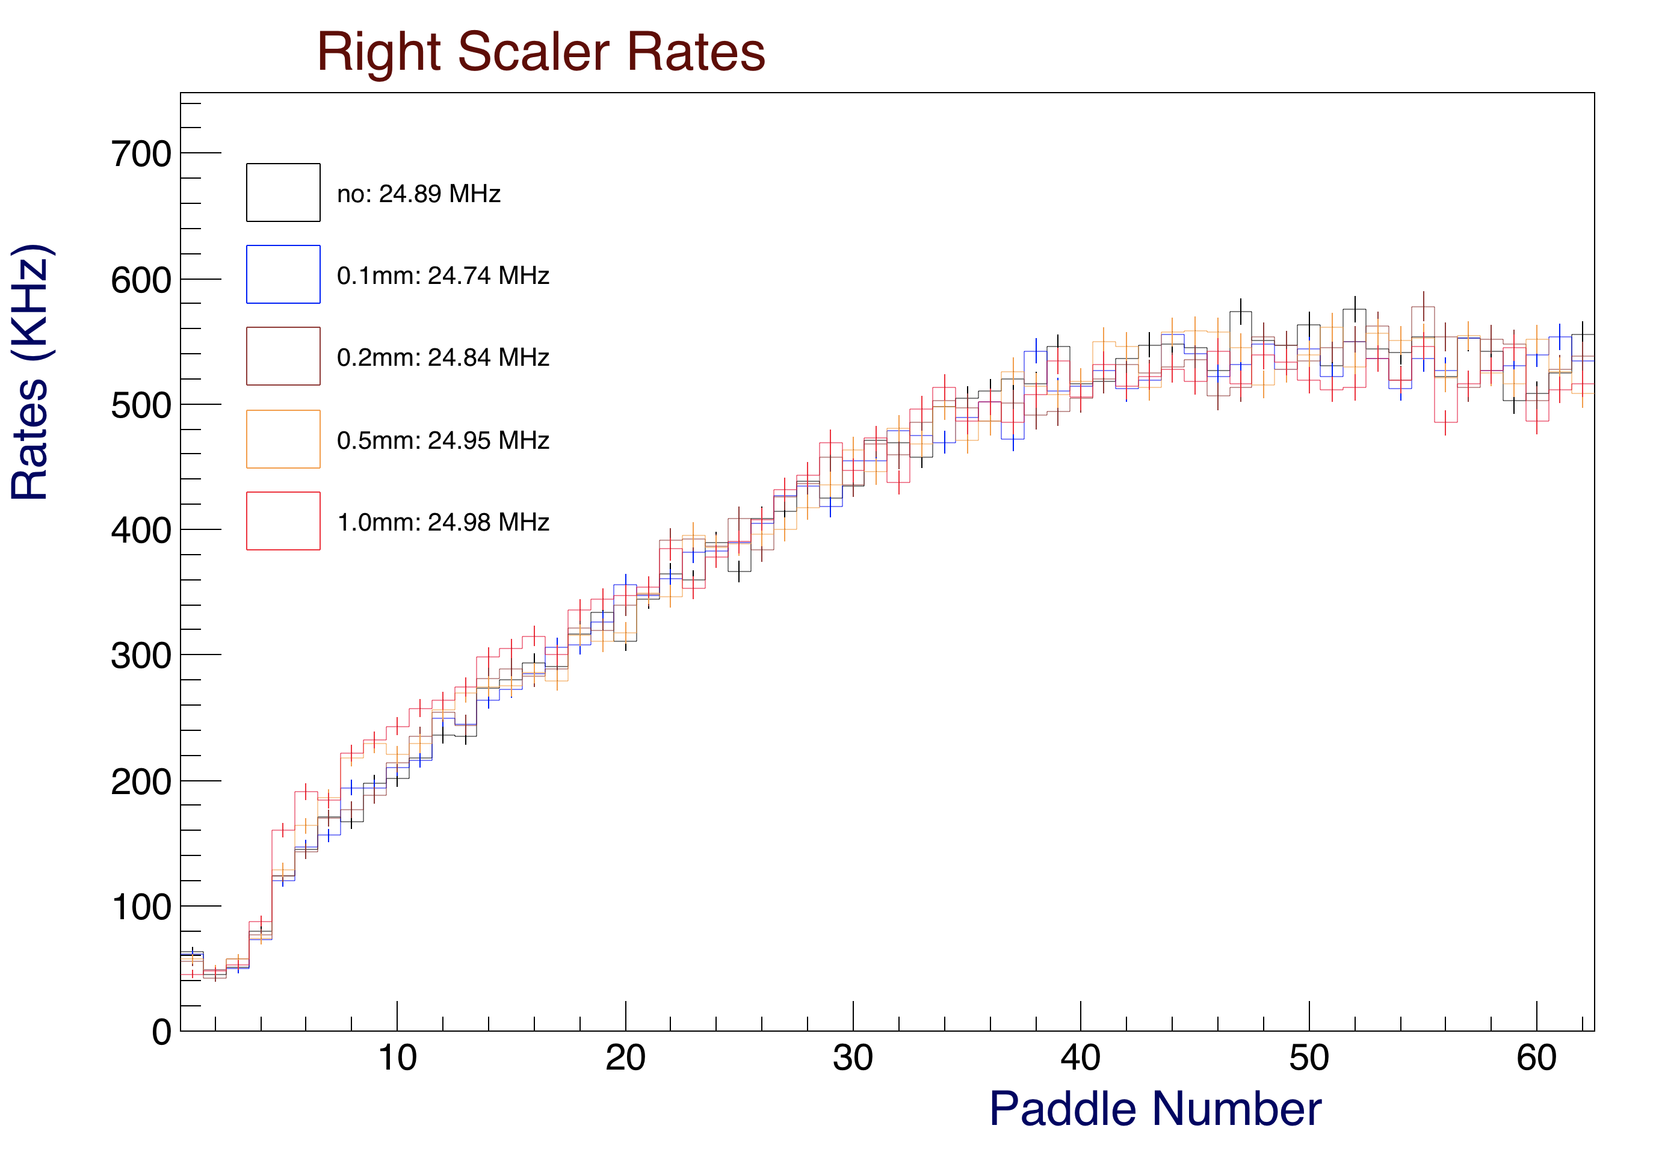

*Figure 17: Right scaler rates for the FTOF panel-1b PMTs for different configurations with a 1 MeV energy threshold. As expected, they are nearly identical to the left scaler rates of Fig. 16.*

**Simulated FTOF PMT Anode Currents**

The FTOF panel-1b PMT anode currents were calculated based on the attenuated energy at the location of the left/right PMTs using a flat conversion factor of 0.00002768 C/MeV.

The computed left PMT anode currents are shown in Figures 18. The right currents are identical.

The increased rate at small angle for the thickest 1 mm shield is reflected in the current rates as well.

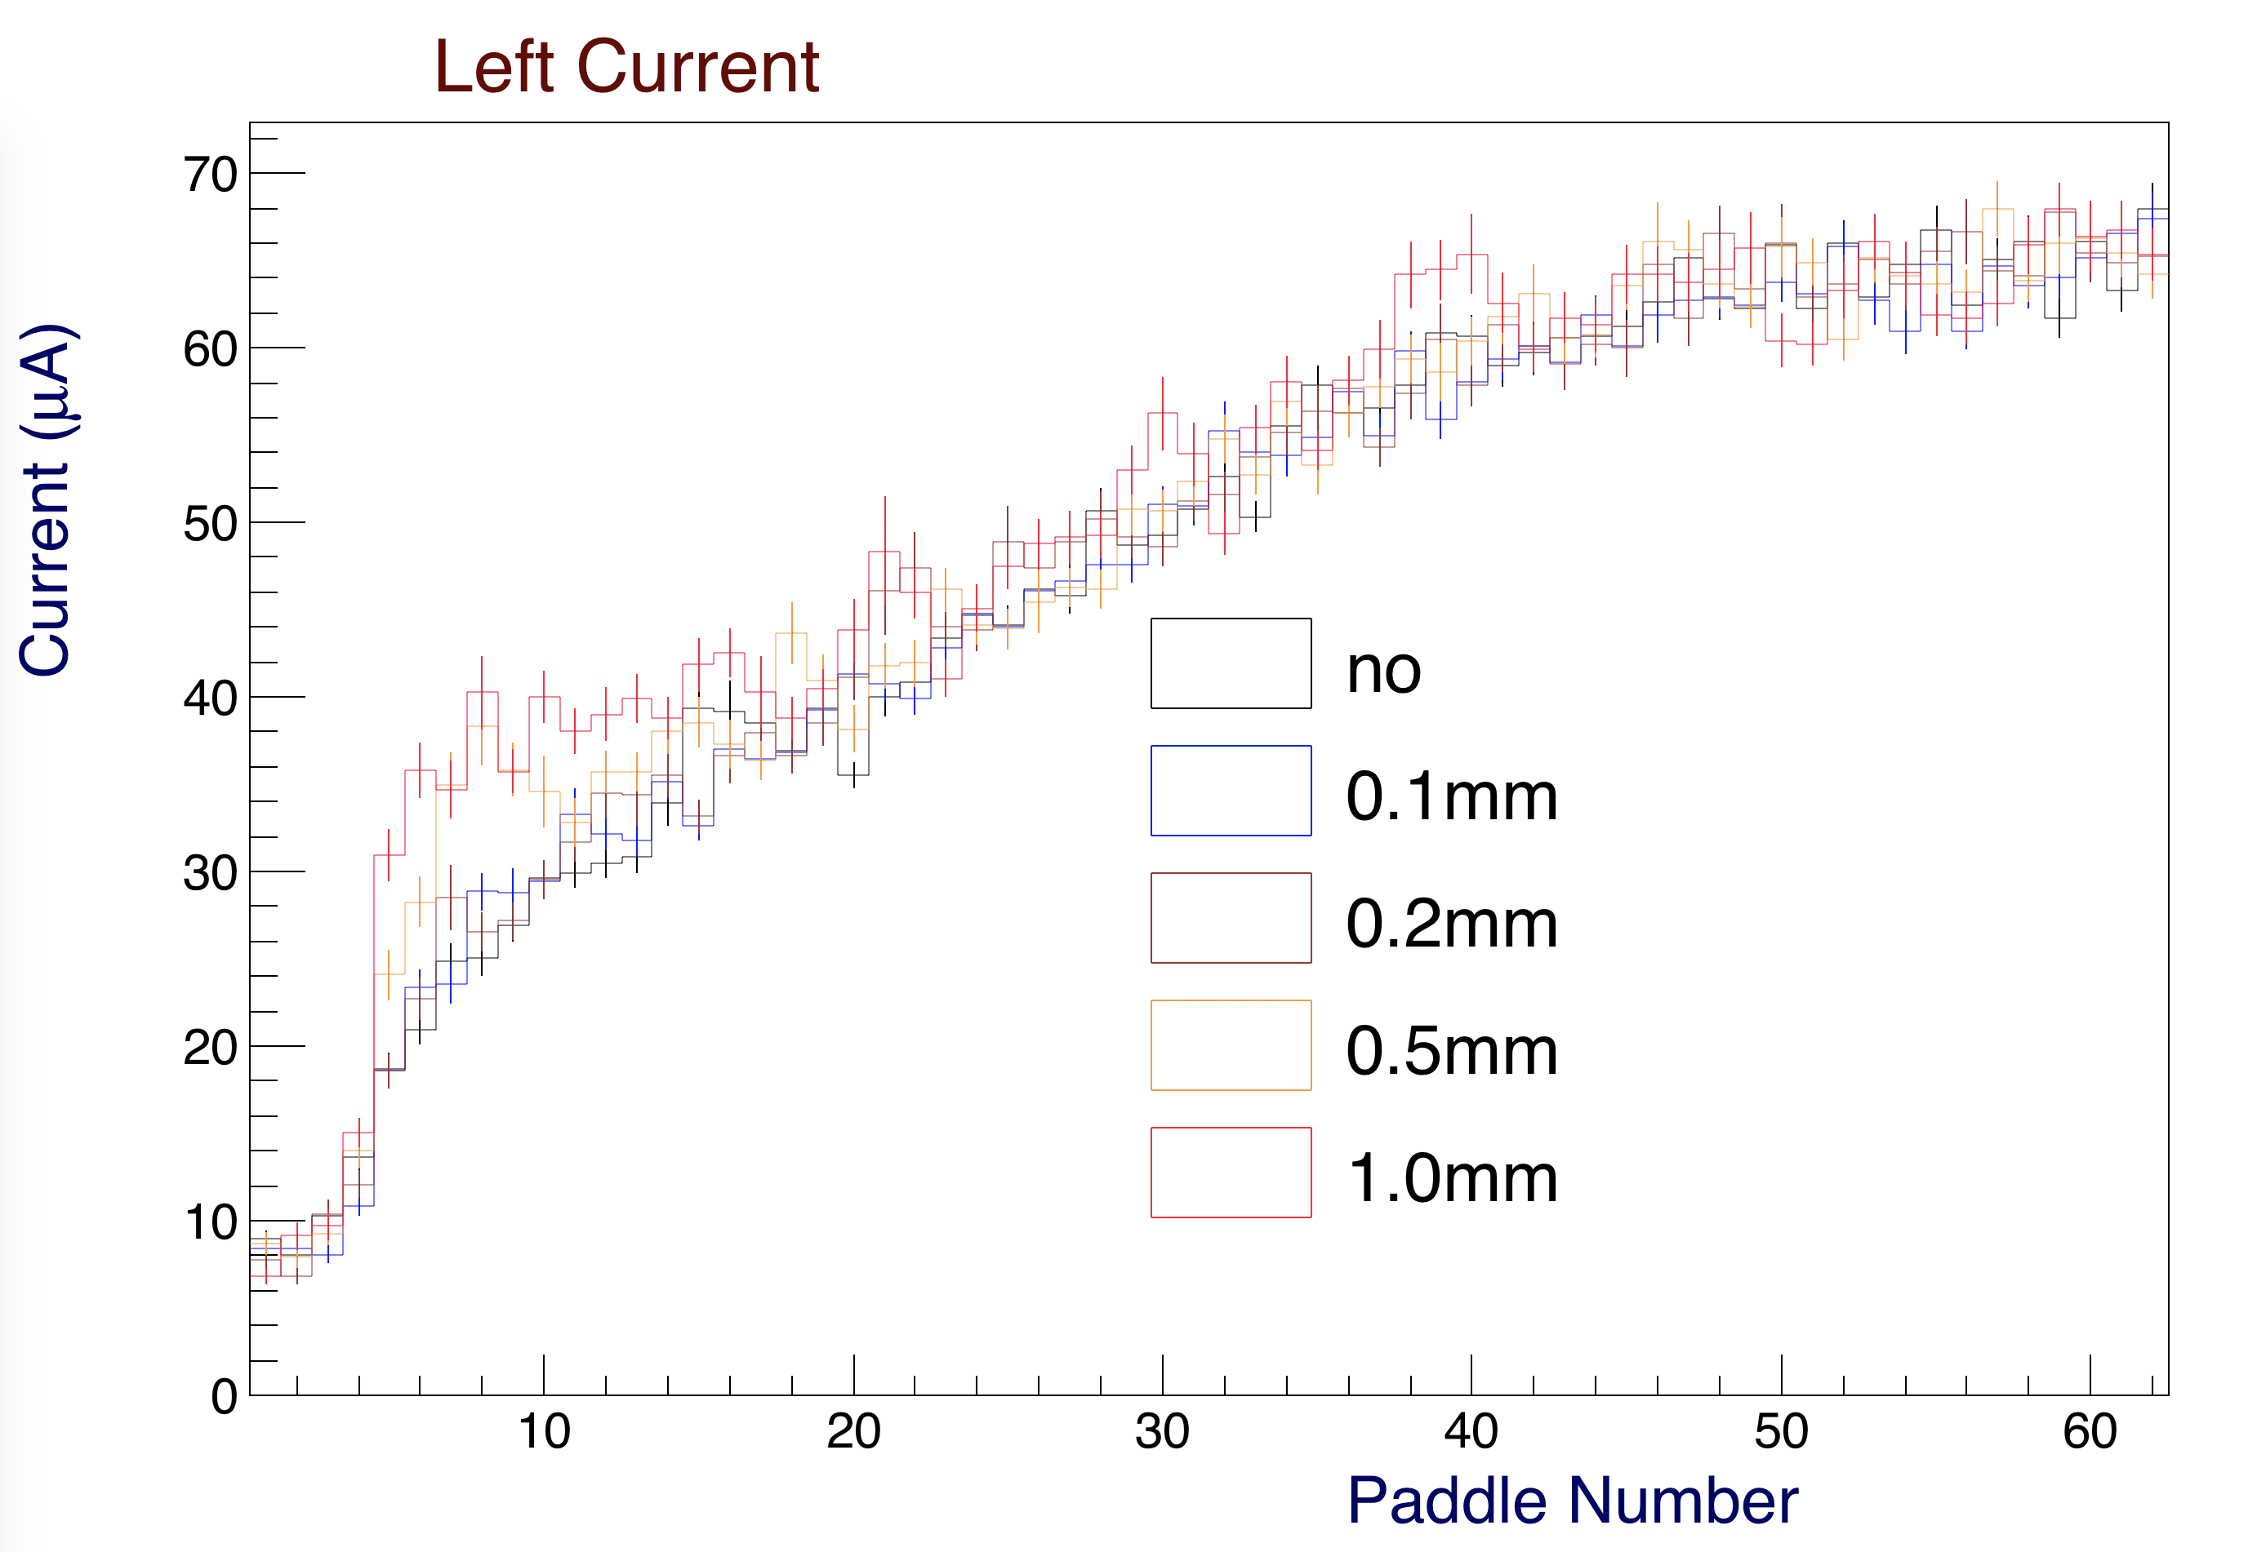

*Figure 18: Left PMT anode currents (A) in the FTOF panel-1b PMTs for the different shielding configurations. The current is unaffected by the shielding except for the 1mm lead sheet, which increases the rates at small angles. This plot is for the full nominal CLAS12 operating luminosity.*

**FTOF Rates and PMT Currents from Direct Measurements**

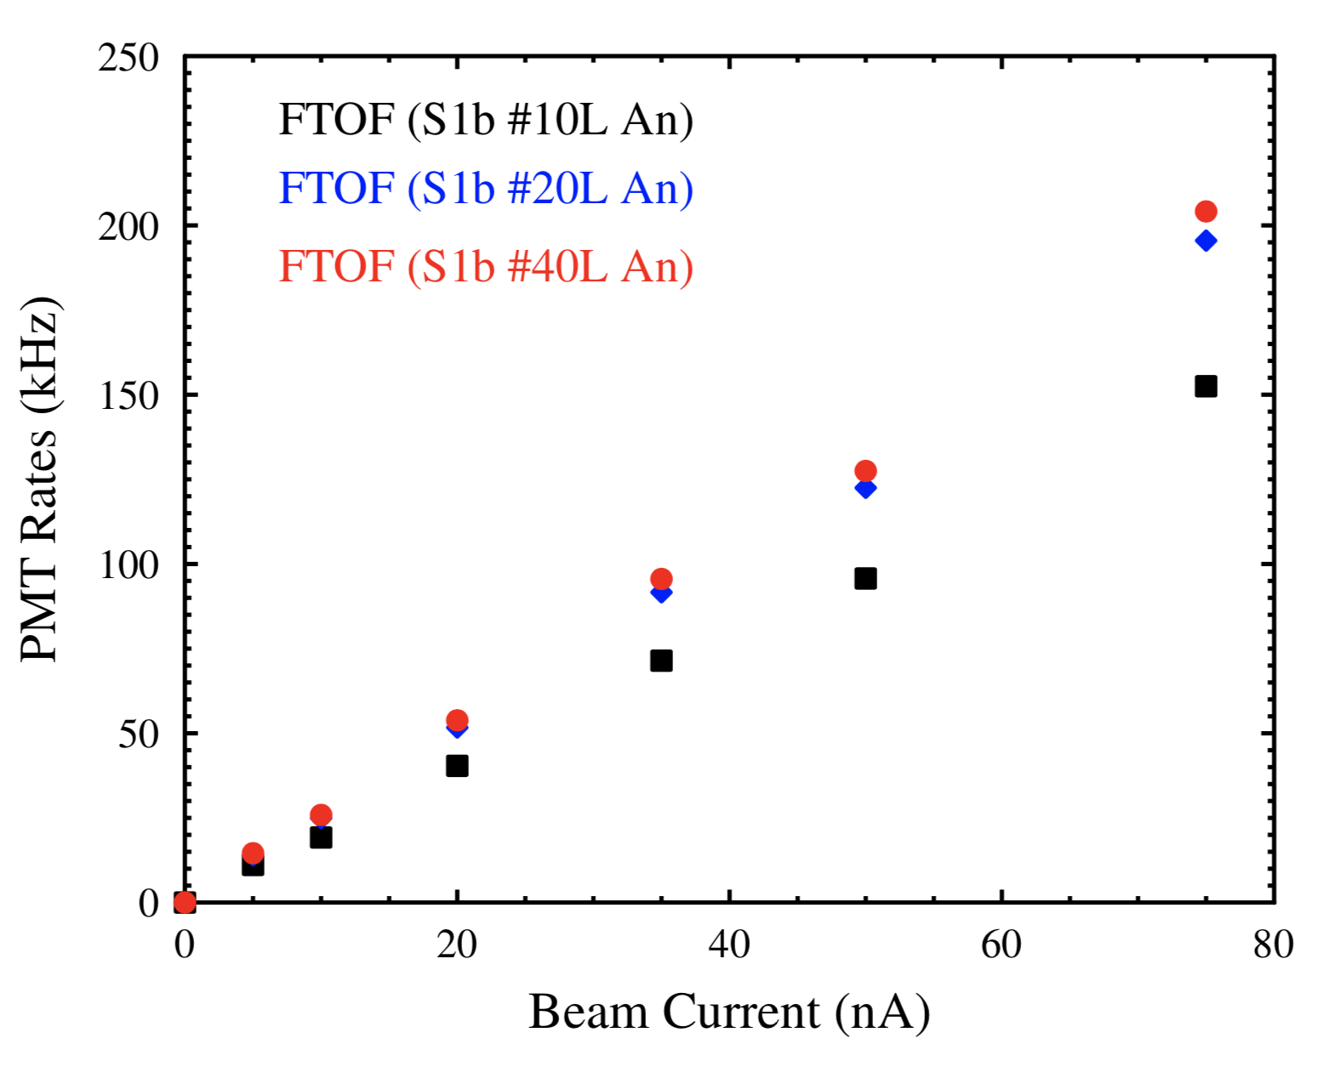During beam operations the average left and right panel-1b PMT scaler rates based on the FADC readout with a 1 MeV energy threshold applied were recorded as a function of beam current. These data are shown in Figure 21. A direct comparison to the Monte Carlo results shown in Figures 16 and 17 show that the actual measured rates at the full operating luminosity of CLAS12 (75 nA) are about a factor of 2-3 lower than the simulation predictions (150-200 kHz for data, 500 kHz for simulation).

Figure 21: Measured average FTOF panel-1b PMT counting rates (kHz) vs. beam current (nA) for PMTs 10L, 20L, and 40L.

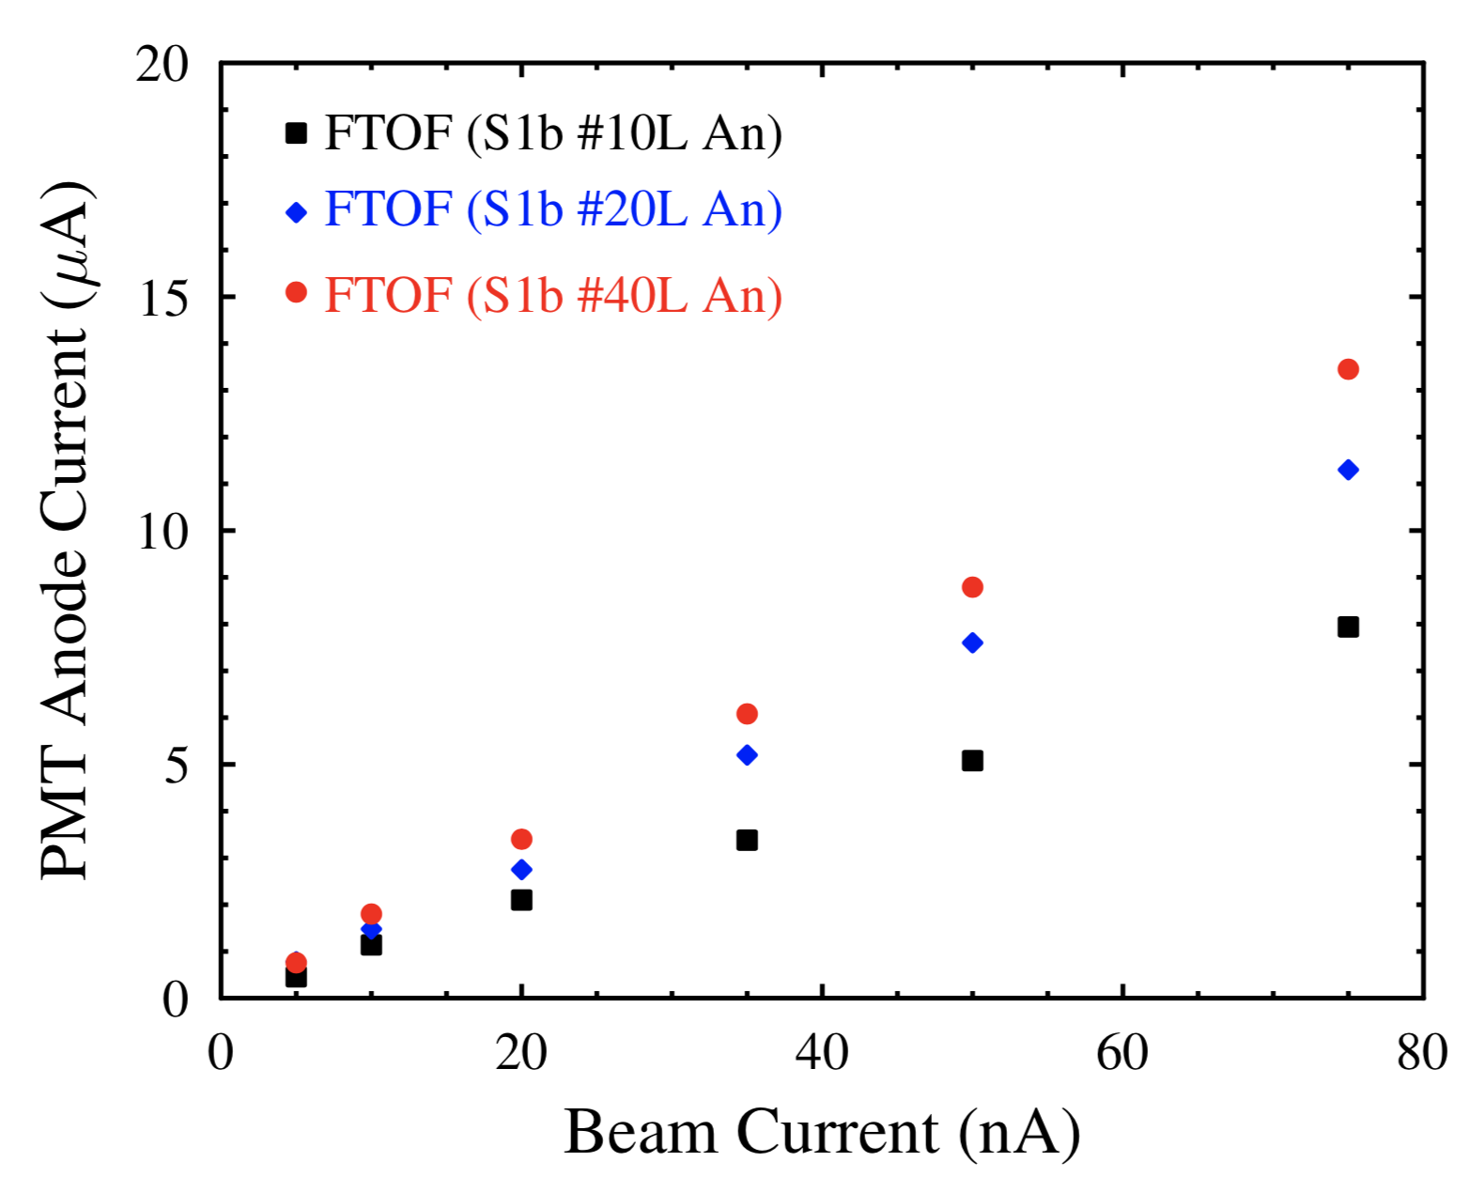

Figure 22: Measured PMT anode current (A) vs. beam current (nA) for panel-1b PMTs 10L, 20L, and 40L.

Direct measurements of the FTOF PMT anode currents were made for three panel-1b PMTs vs. beam current as shown in Figure 22. At the full nominal operating luminosity of CLAS12 the measured PMT anode current (10 A) is at least a factor of three smaller than that computed from simulations. This follows from the difference in predicted rates from simulation from the data.

**Physics Processes**

The gemc simulation catalogues the process ID that generated a particle. In Figure 23 the longitudinal vertex is plotted against the process ID for the 1mm shield. At the right of the picture the process ID catalogues (below 41, the most relevant for this study) are referenced.

Compton scattering is the main process happening inside the FTOF paddles (ID = 2). The hadronic processes have ID >= 7. One can see contributions from the beamline shielding (photo-nuclear), then hadronic elastic within the FTOF paddles.

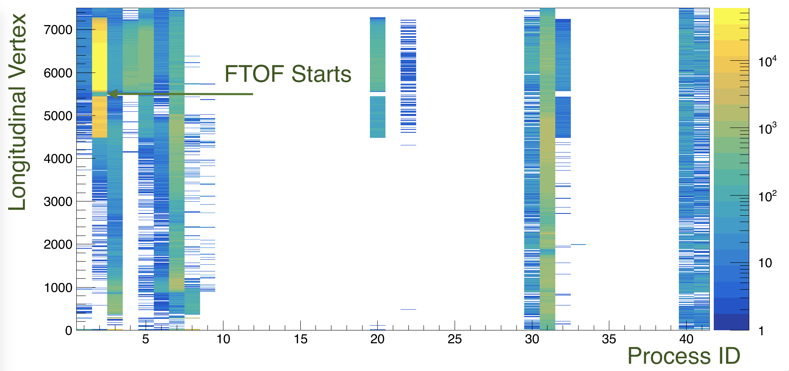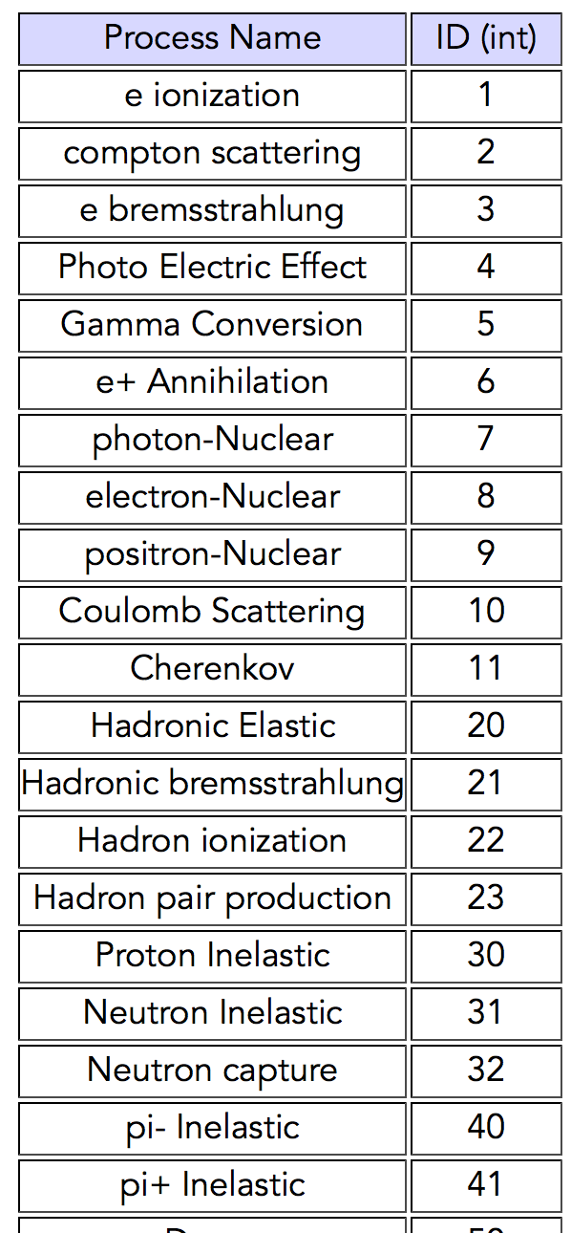

*Figure 23: Left: Longitudinal vertex of particles depositing at least 1 MeV in FTOF panel 1b is shown versus the process ID. Right: process ID catalogue.*

In Figure 24 the transverse vertex of particles depositing at least 1 MeV in FTOF is plotted versus the particle ID. One can see the shield responsible for many electrons and pions.

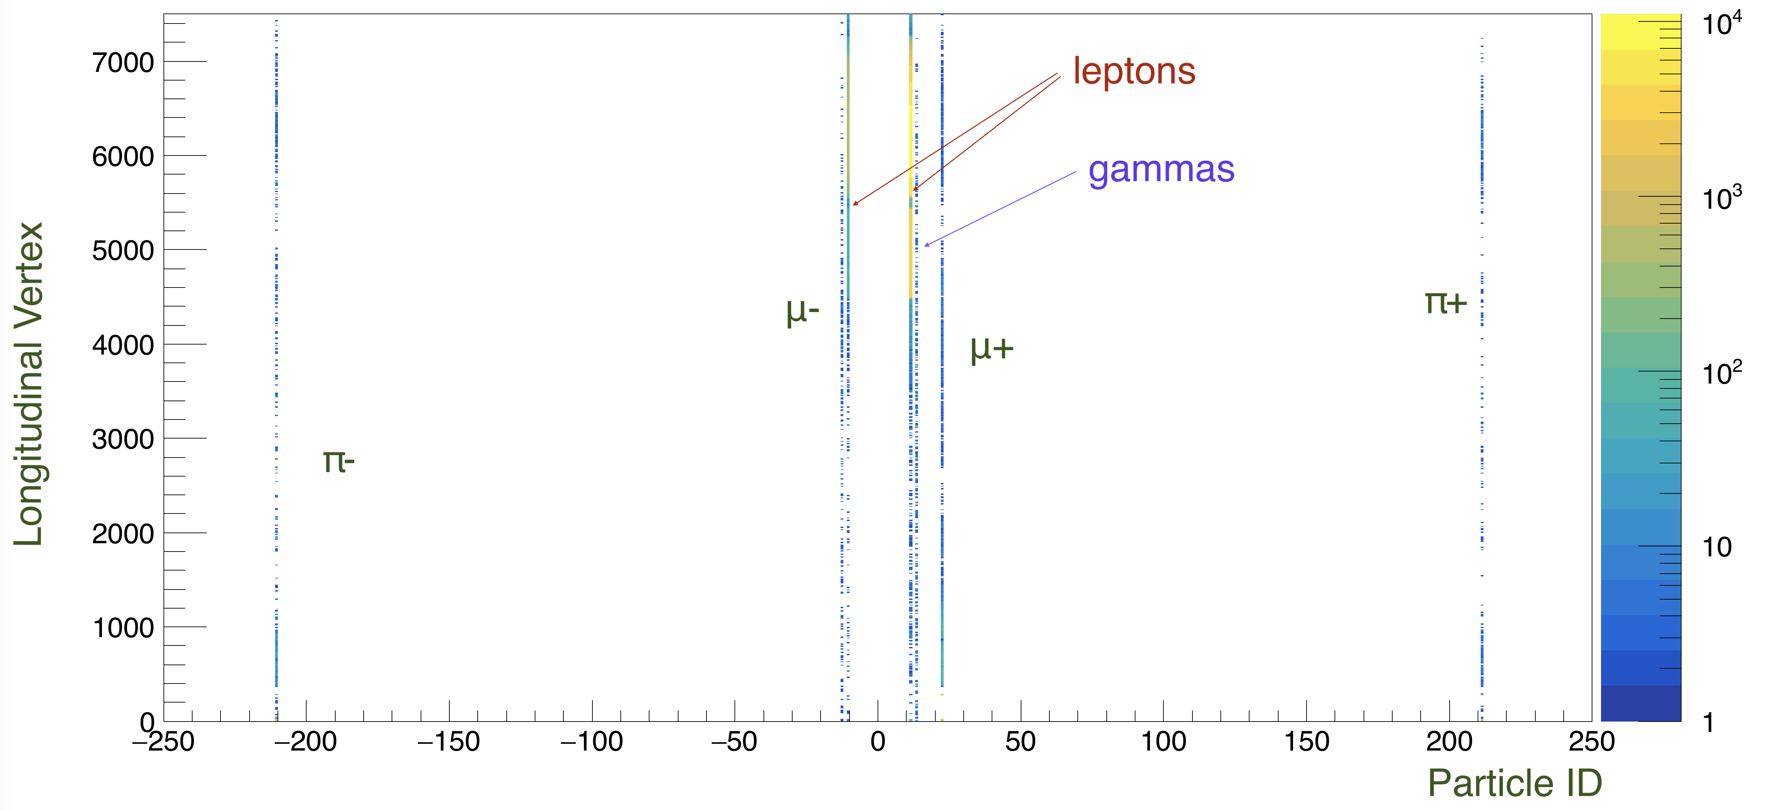

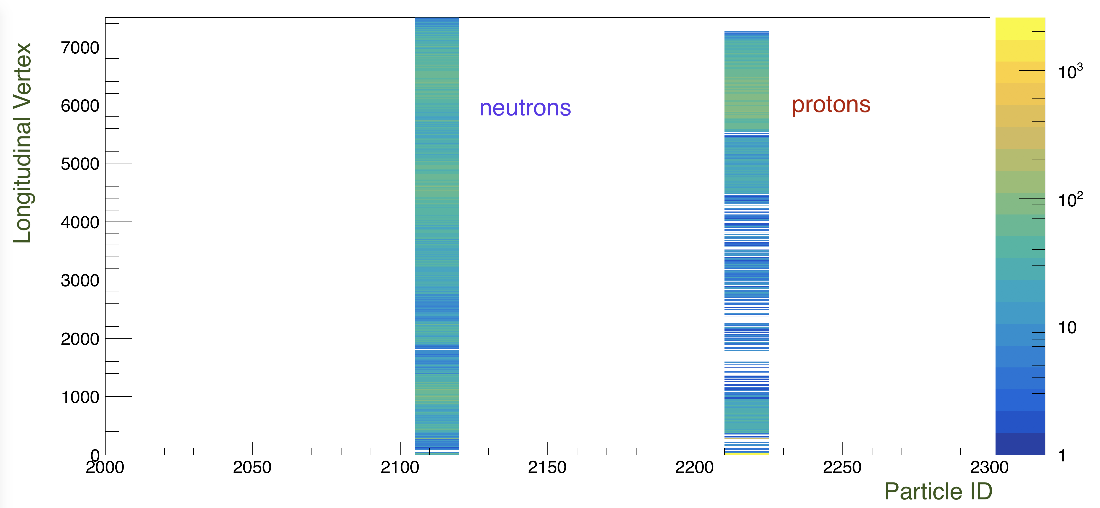

*Figure 24: Longitudinal vertex of particles depositing at least 1 MeV in FTOF panel 1b is shown versus the particle ID. Top: gammas (22), electron positron pairs (11 and -11), muons (13 and -13) and pions (211 and -211). Bottom: protons (2212) and neutrons (2112). Most leptons are produced within the FTOF paddles.*

**Summary and Conclusions**

This note shows predictions from the CLAS12 simulation for the FTOF counter rates with different shield configurations. These include 4 different lead shields in front of panel 1b if 0.1, 0.2, 0.5, and 1 mm. The simulation also provides predicted counting rates and PMT anode currents that can be compare directly against beam measurements with the FTOF.

From this study three conclusions can be drawn:

1. There is no shielding solution using lead in front of panel 1b that provides a significant reduction of rates or currents. The simulation shows that the rates of low-energy background are significantly reduced, but that due to conversions in the added shielding material, the overall energy deposited in the FTOF remains unchanged.
2. The simulation overestimate the PMT rates by at least a factor of two and the anode currents by at least a factor of three. This may be due to effects not accounted for in the simulation, for example electronic noise.
3. The flat conversion factor used to extrapolate anode currents from rates in the simulation may be inaccurate, since the currents are more overestimated than the rates.

**References**

*[1] M. Ungaro,* ***CLAS12-Note 2017-013****:* Corrections to CLAS12 target design.

*[2] V. Burkert, D.S. Carman, L.C. Smith, and M. Ungaro,* ***CLAS12-Note 2018-006****:* Study of Tungsten Shielding Before CTOF to Limit its PMT Currents

**Appendix A: Paddles attenuation length and paddle lengths.**

Data is ordered with paddle number.

139.08 17.27

143.16 23.62

147.25 30.08

151.32 36.43

155.40 42.89

159.48 49.24

163.56 55.70

167.64 62.05

171.72 68.51

175.80 74.86

179.88 81.32

183.97 87.67

188.04 94.13

192.12 100.48

196.20 106.94

200.28 113.29

204.36 119.75

208.44 126.10

212.52 132.56

216.60 138.91

220.69 145.37

224.76 151.72

228.84 158.17

232.92 164.52

237.00 170.98

241.08 177.33

245.16 183.79

249.25 190.14

253.32 196.60

257.40 202.95

261.48 209.41

265.57 215.76

269.64 222.22

273.72 228.57

277.80 235.03

281.89 241.38

285.96 247.84

290.04 254.19

294.13 260.65

298.20 267.00

302.28 273.46

306.36 279.81

310.45 286.27

314.52 292.62

318.60 299.08

322.69 305.43

326.76 311.88

330.84 318.23

334.92 324.69

339.01 331.04

343.08 337.50

347.16 343.85

351.25 350.31

355.32 356.66

359.40 363.12

363.48 369.47

367.57 375.93

371.64 382.28

375.72 388.74

379.80 395.09

383.88 401.55

387.96 407.90